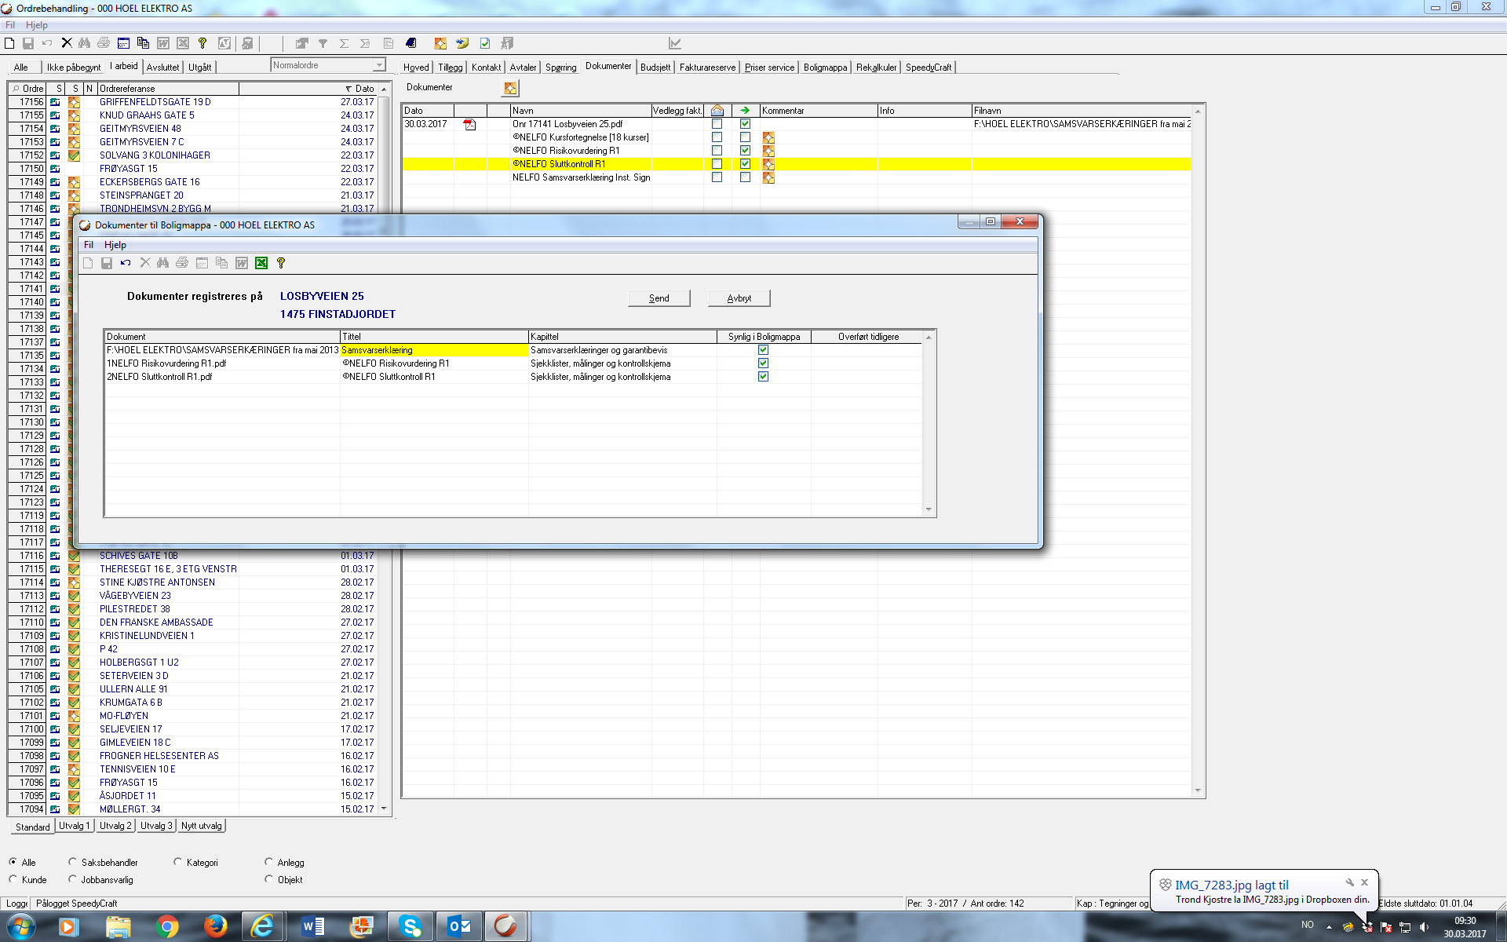

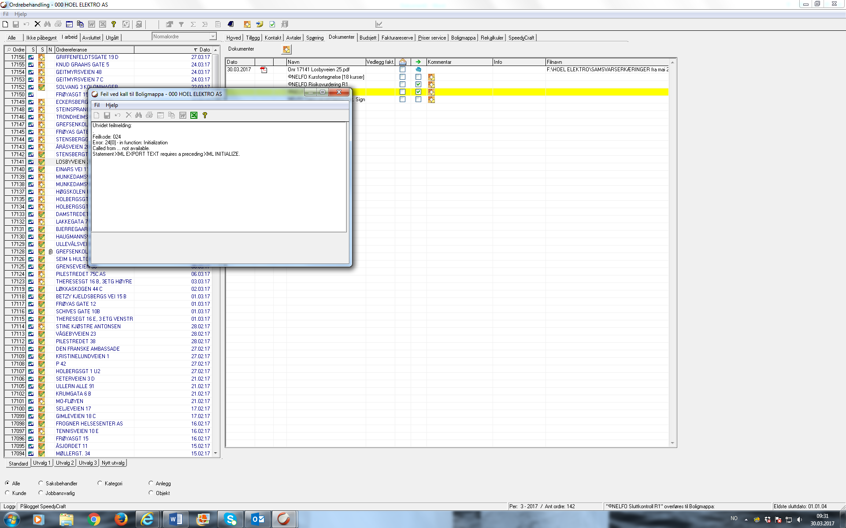

Feilmelding sier: Utvidet feilmelding: Feilkode 024 Error 24(0) – in function, Initialzation Called from… not avaliable Statement XML EXPORT TEXT requires a preceding XML INITIALIZE

