YouServe login manual
March 2025



Table of content
Where can you log in? 2
First time login 3
Activate account 3
Set up two-factor authentication 4
Visma Authenticator 5
Microsoft Authenticator 9
Google Authenticator 11
E-mail notifications 15
Personal settings 16
Problems logging in 17
Forgot your password? 17
Reset password 18
One time sign-in link 18
Change Authenticator App (2FA) 19
Log in to your account 19
Go to the ‘Personal Settings’ page 19
Change your authenticator app 20
Link the new authenticator app 21
No access to your authenticator app 22
What is the backup code? 22
How do you get a backup code? 22
Use the backup code 22

Where can you log in?
You can easily log in to My YouServe via https://my.youserve.nl
After you click on the link, the login screen will appear. You can log in with your private email address or your business email address.

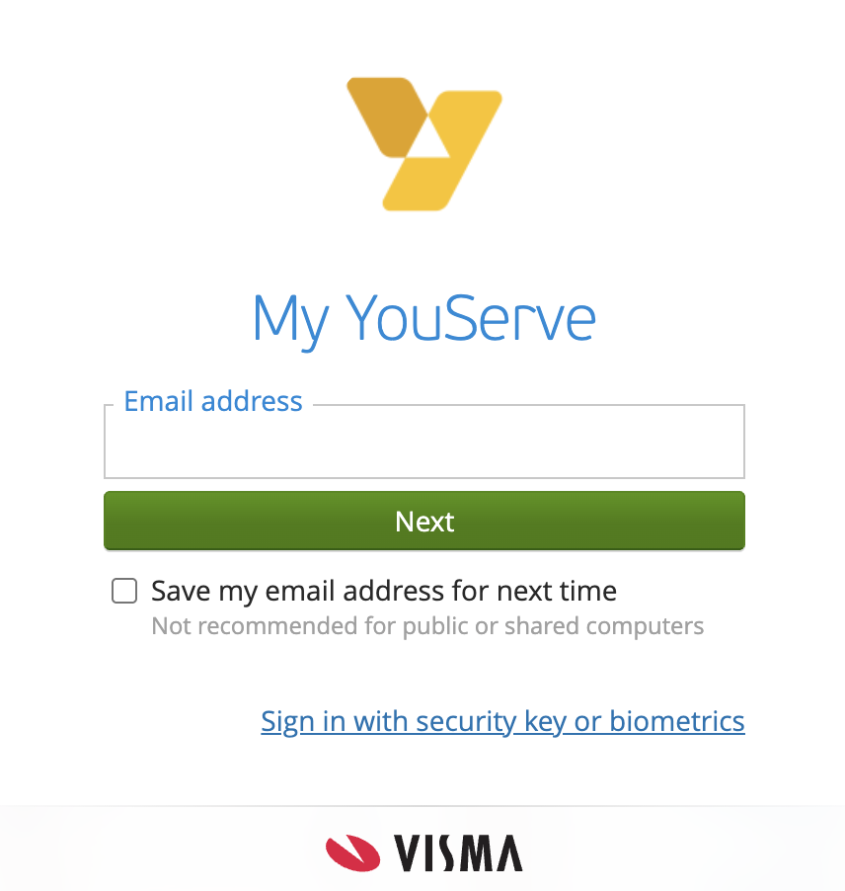

Note: The language of the login screen is determined by your browser's preferred language settings.

First time login

Activate account
Once the YouServe administrator has created an account for you, you will receive an email to start activating your account.

Step 1: Click the button in the email to activate your account.
Please note: This link is valid for 24 hours and only works once. If the link does not work, you can copy it to your browser.
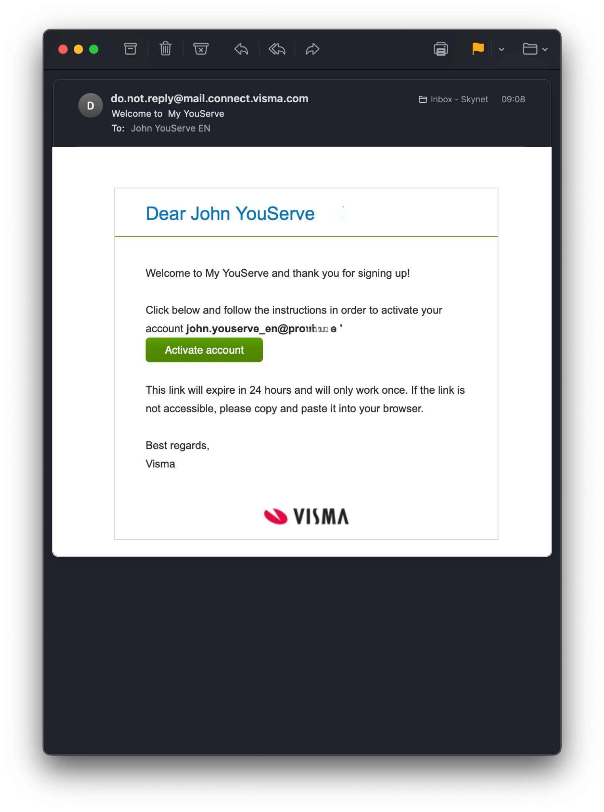
Didn't receive an email? Please check your spam box (junk mail folder) first.

If the link has expired, the user will get the option to request a new valid link after clicking the button in the email. This brings up the following screen.
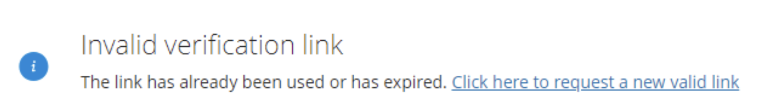
When clicking on “Click here to request a new valid link“, the user will get this screen where he needs to pass Re-Captcha check and will receive an email with the subject “Change password request“
Step 2: Enter the password you want to use for your account and confirm it. Please note the conditions that your password must meet. These are shown on the screen. Click on the ‘set password’ button to save your chosen password.
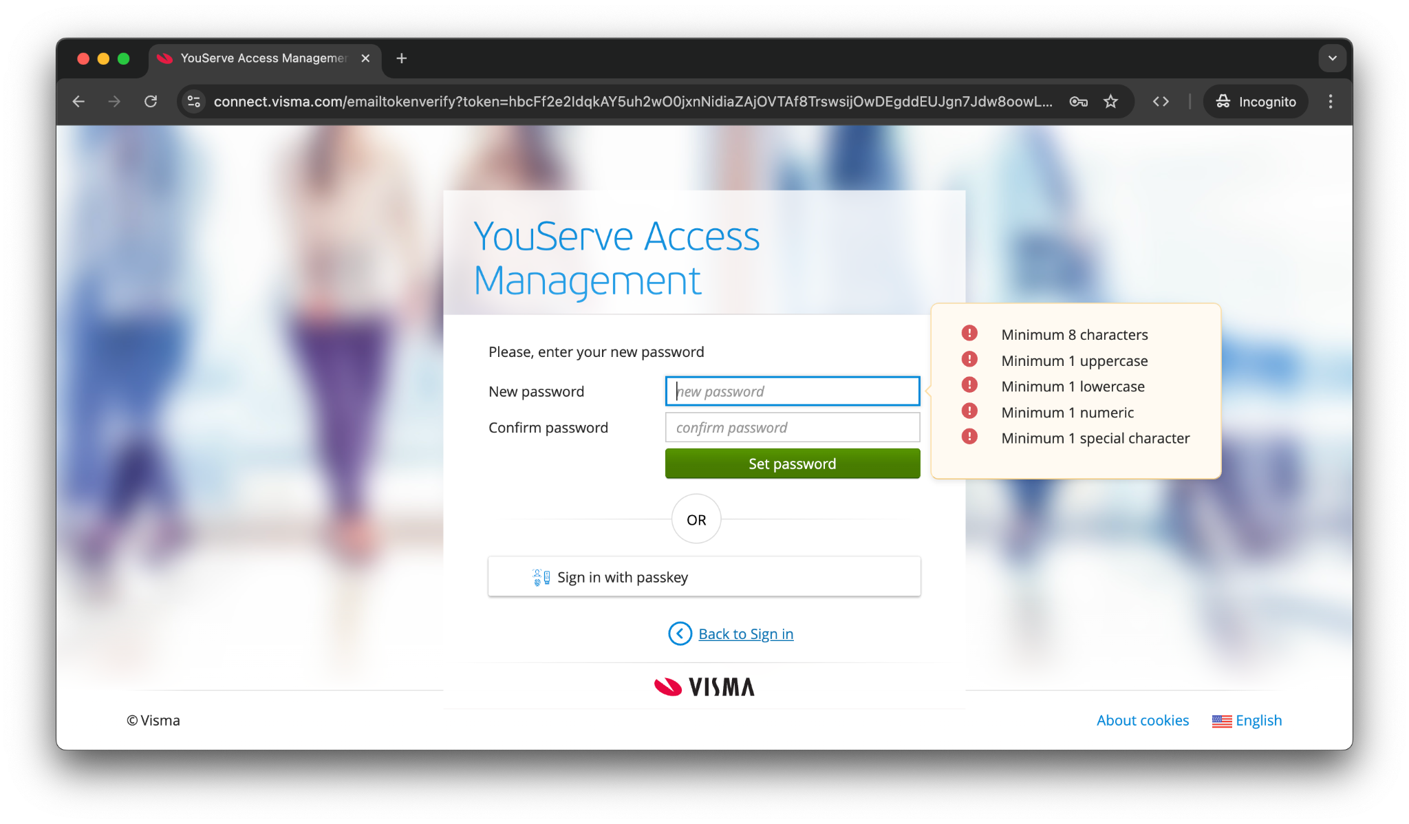
Note: Because your account was created using the YouServe Access Management application, its name appears on this screen.

Set up two-factor authentication
Step 1: Click 'next' to set up your multi-factor authentication
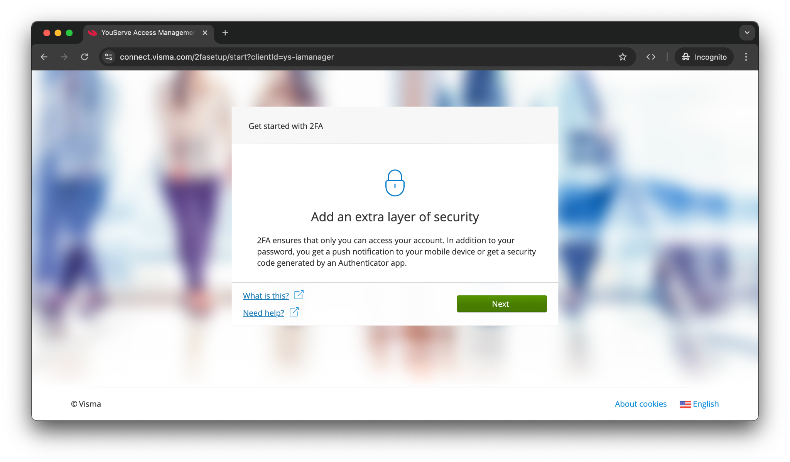
Step 2: Download the Visma Authenticator app or one of the following apps of your choice if you have not already downloaded this app on your phone:
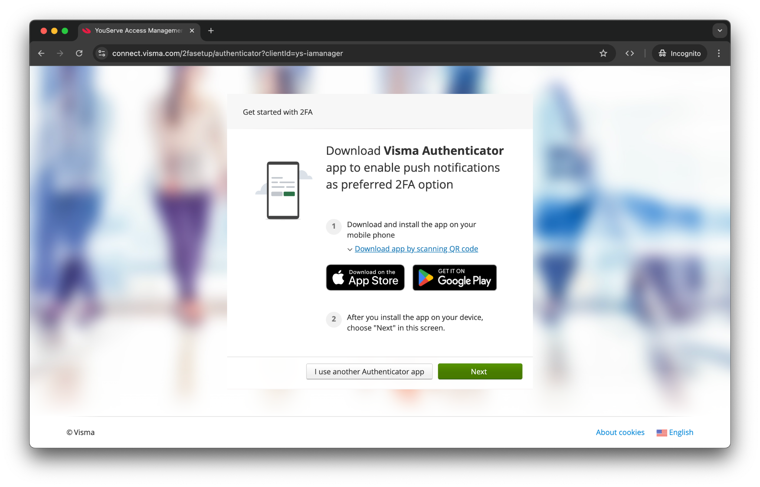
- Visma Authenticator
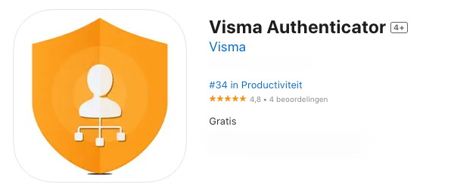
- Microsoft Authenticator
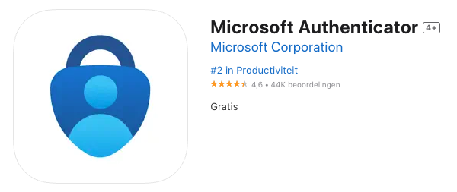
- Google Authenticator
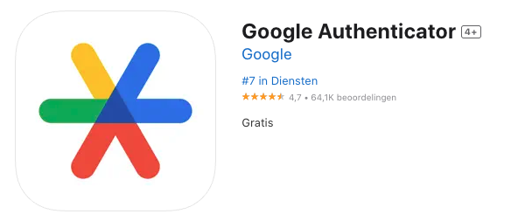

Visma Authenticator
If you would like to use the Visma Authenticator, please follow the steps below:
Step 3: Click 'next' on the screen of the previous step
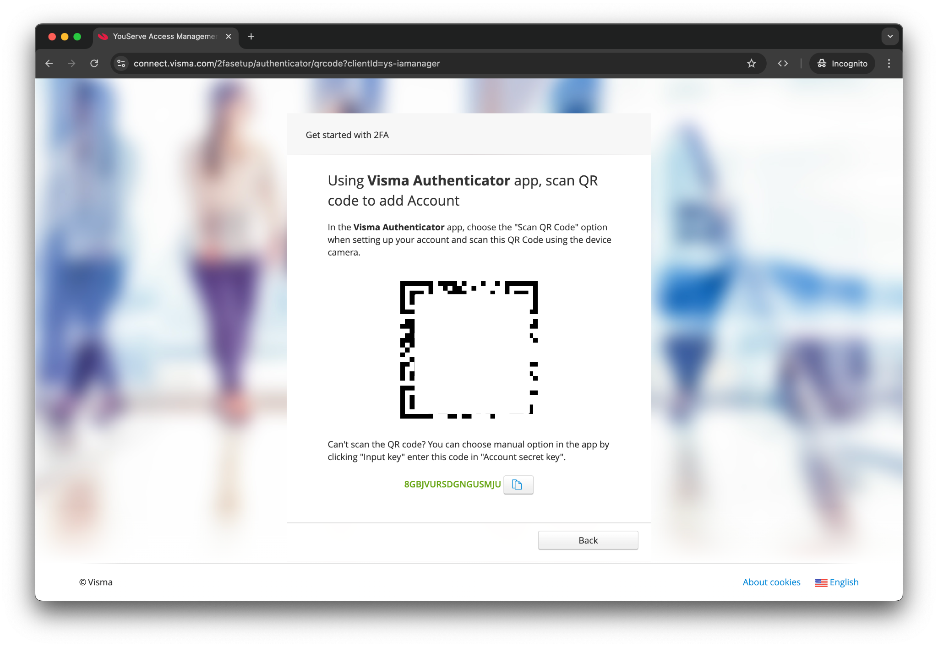
Step 4: Open the Visma Authenticator app
Step 5: Click on the plus sign at the top right. You can now log in with your email address or scan the QR code
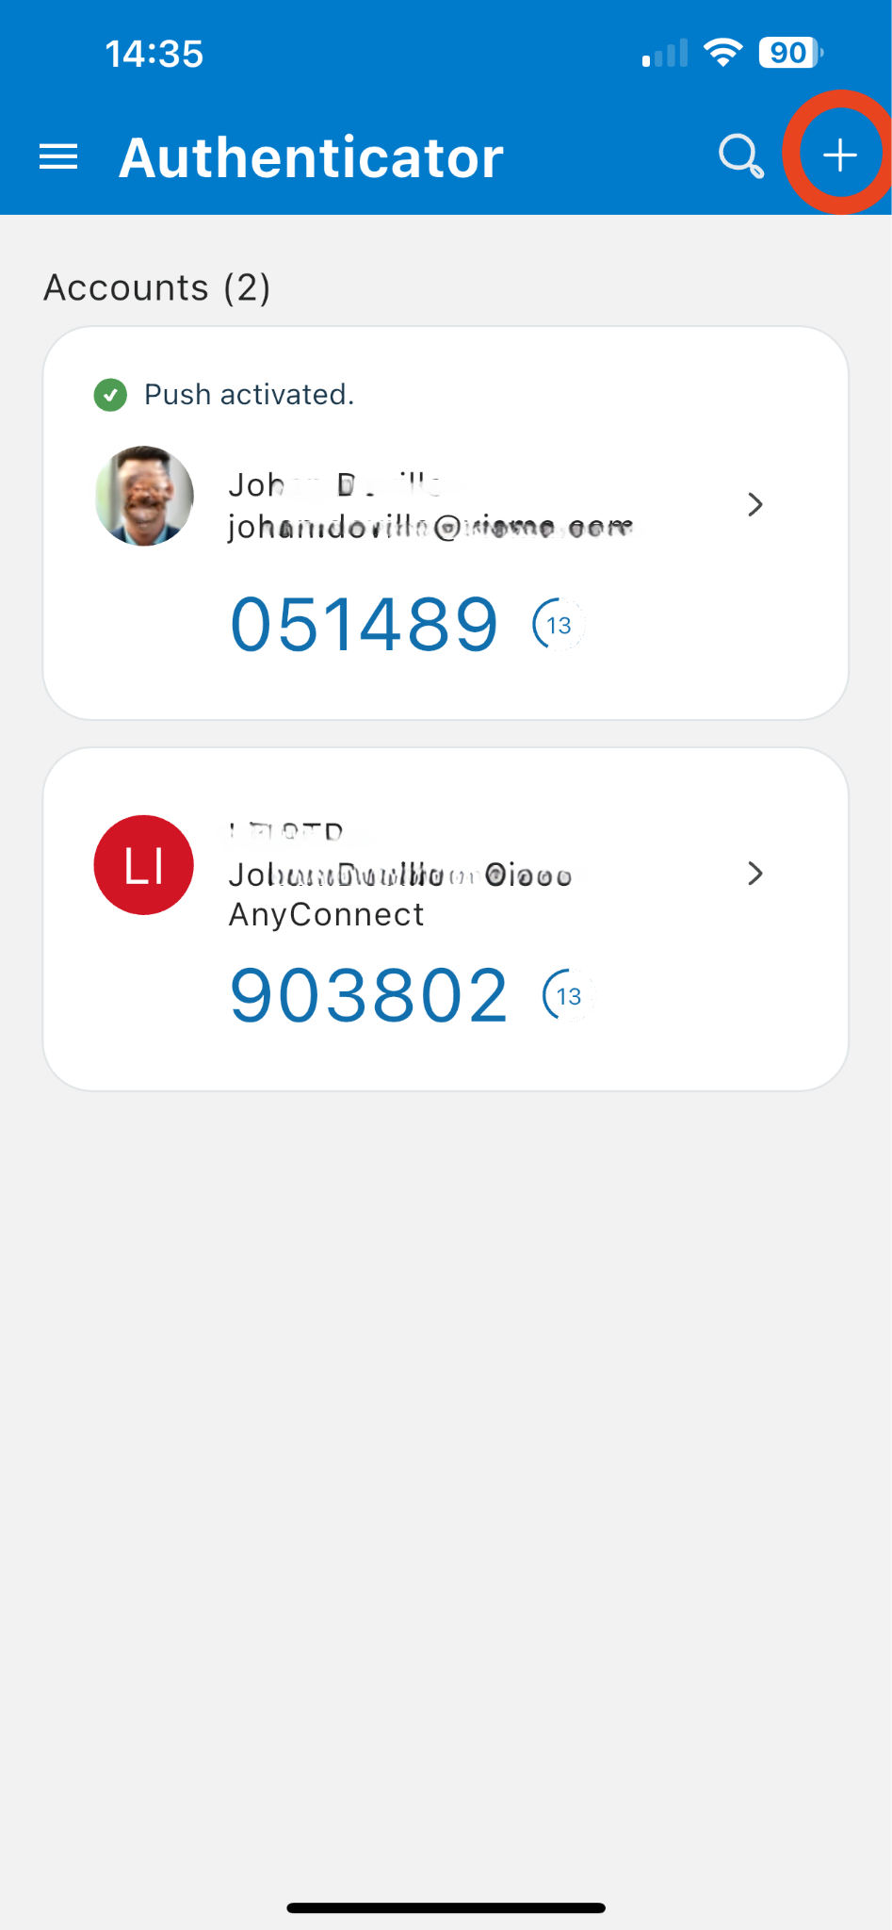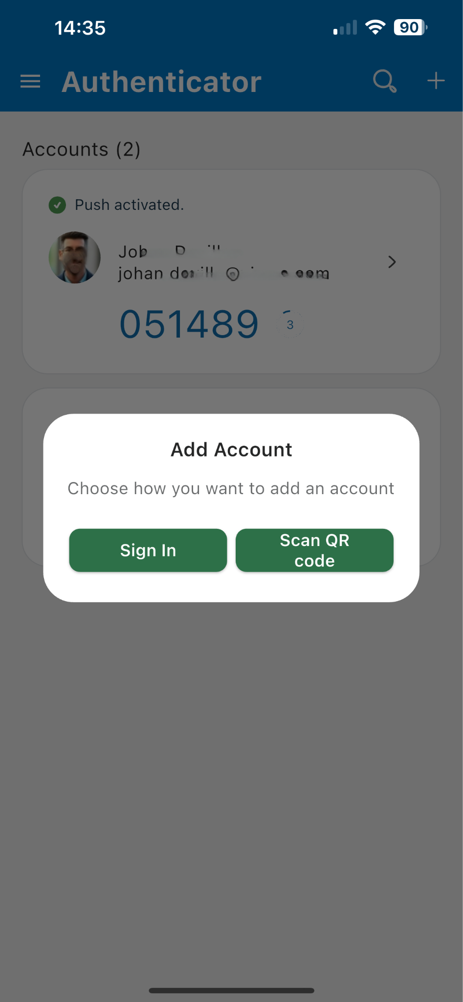
Step 6: Scan the QR code on your screen
Step 7: Click Accept
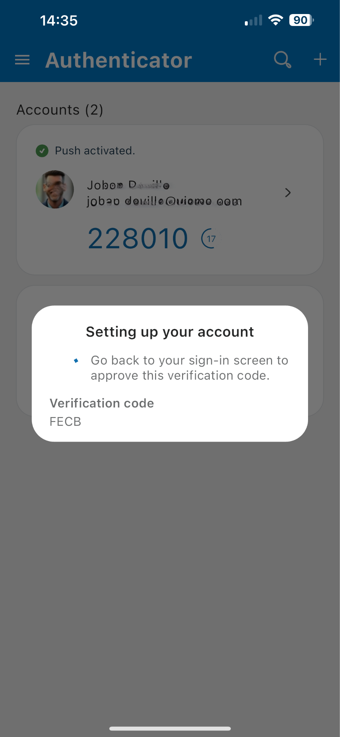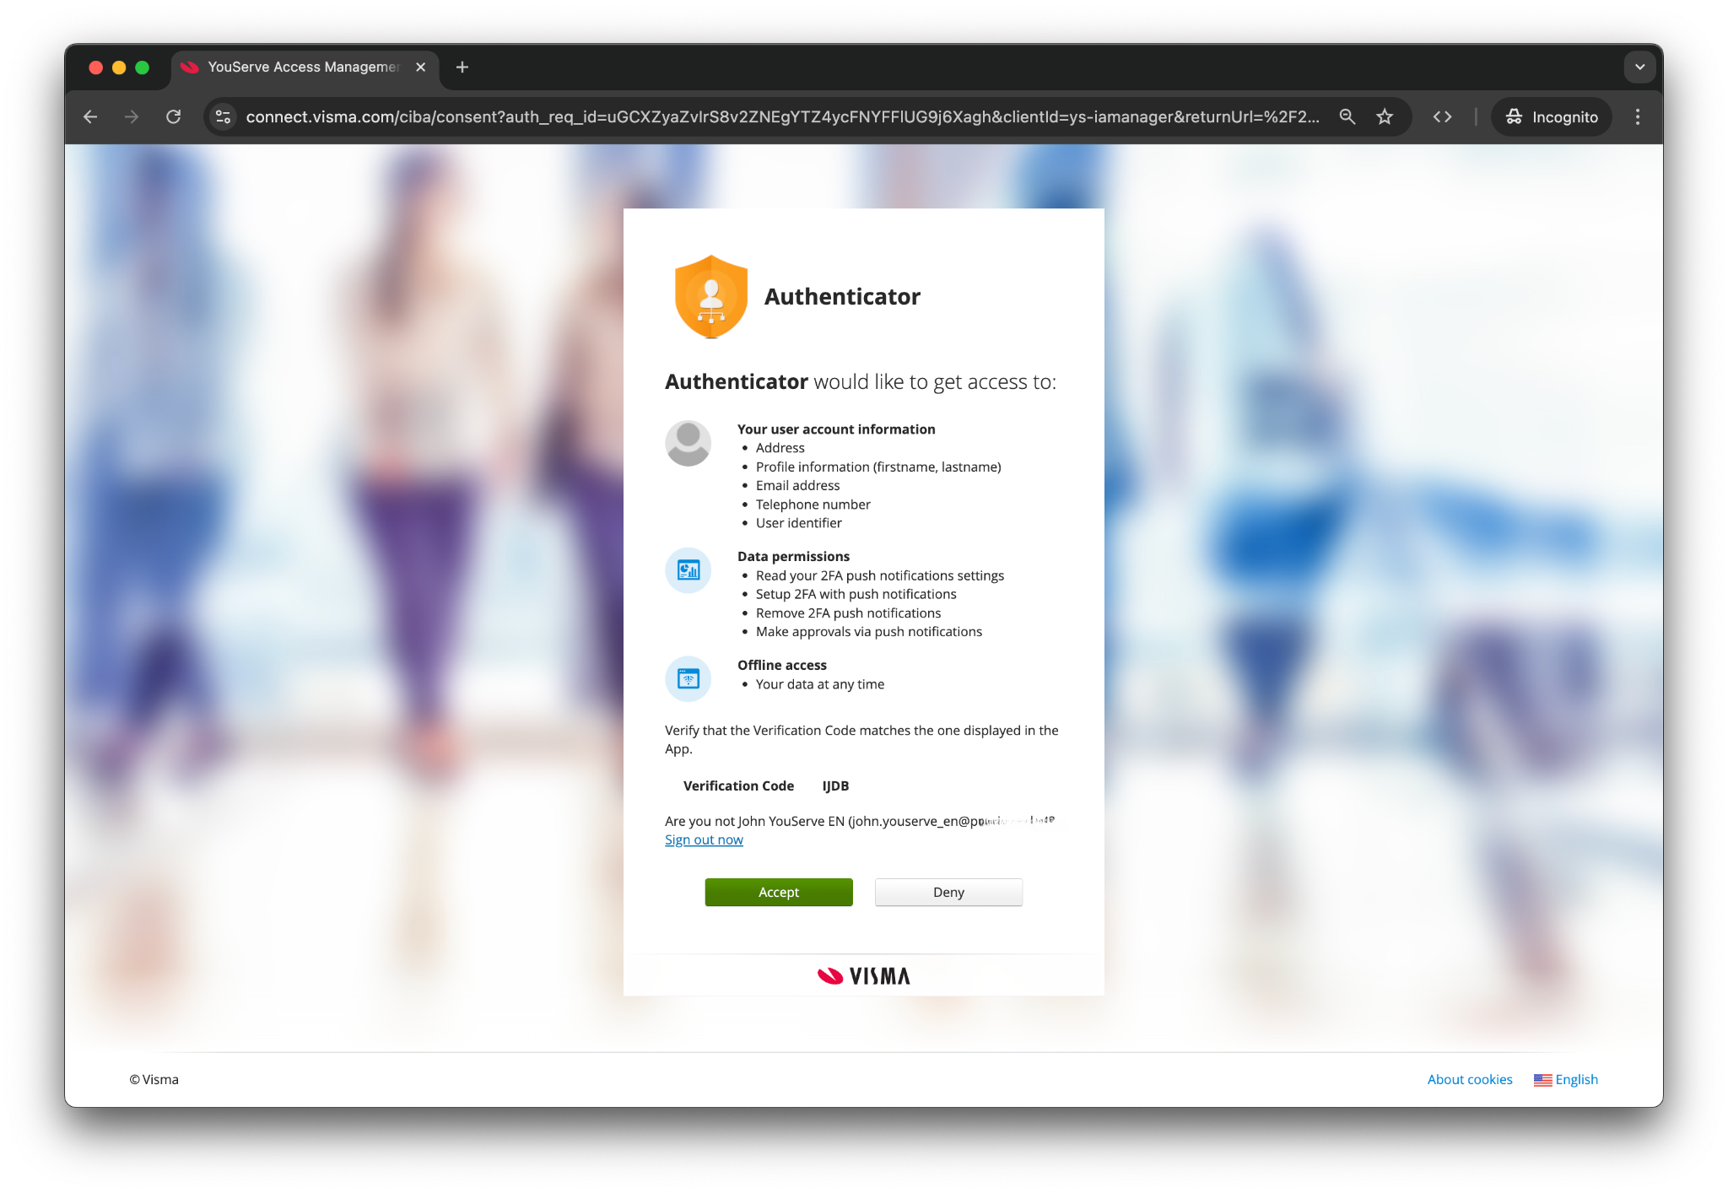
Step 8: The option has now been added to the Visma Authenticator for your YouServe account

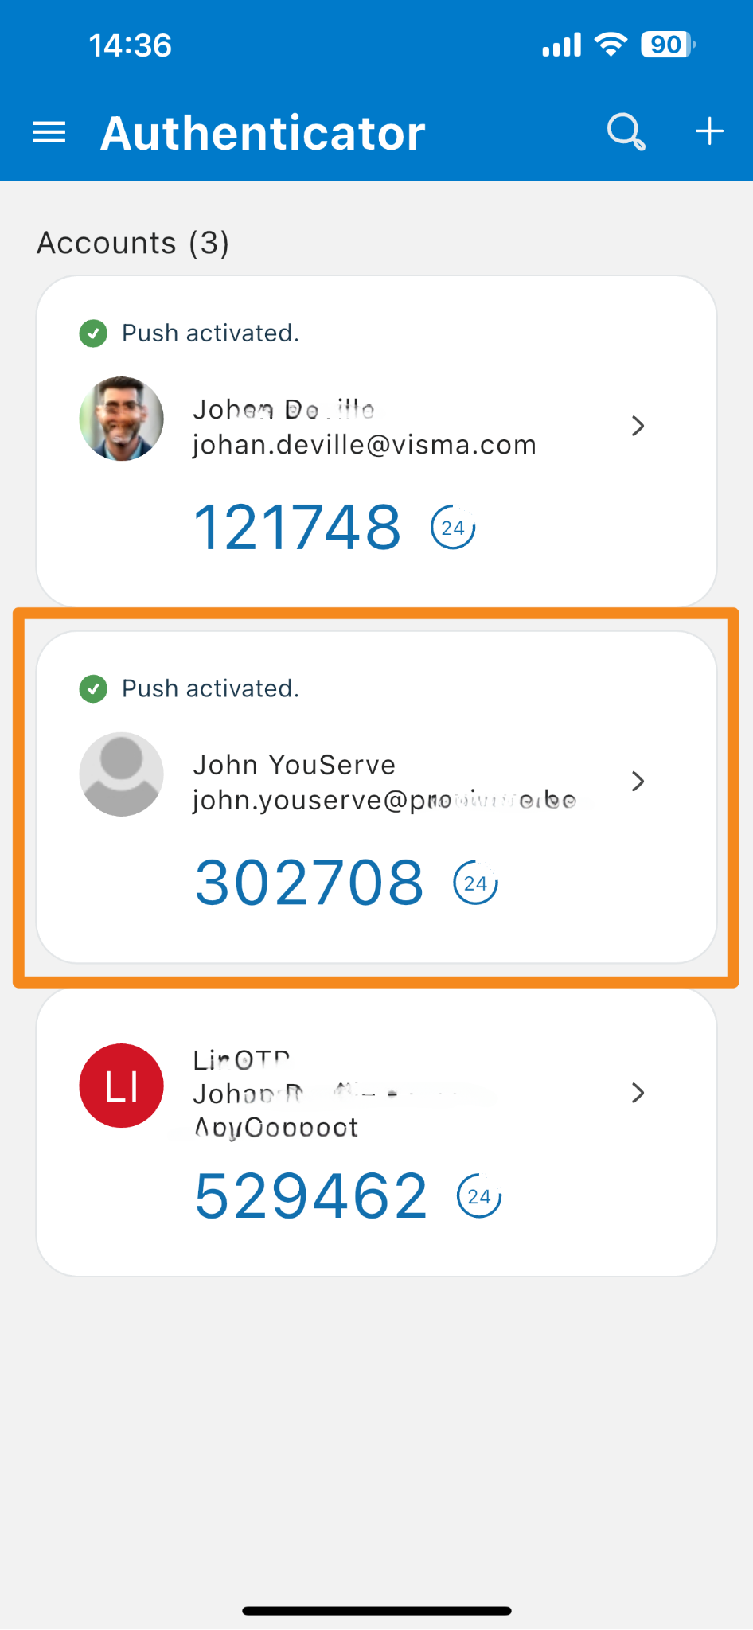

Continue to step 10

Microsoft Authenticator
If you would like to use the Microsoft Authenticator, follow the steps below:

Step 5: Open the Microsoft Authenticator app
Step 6: Click on the plus sign at the top right
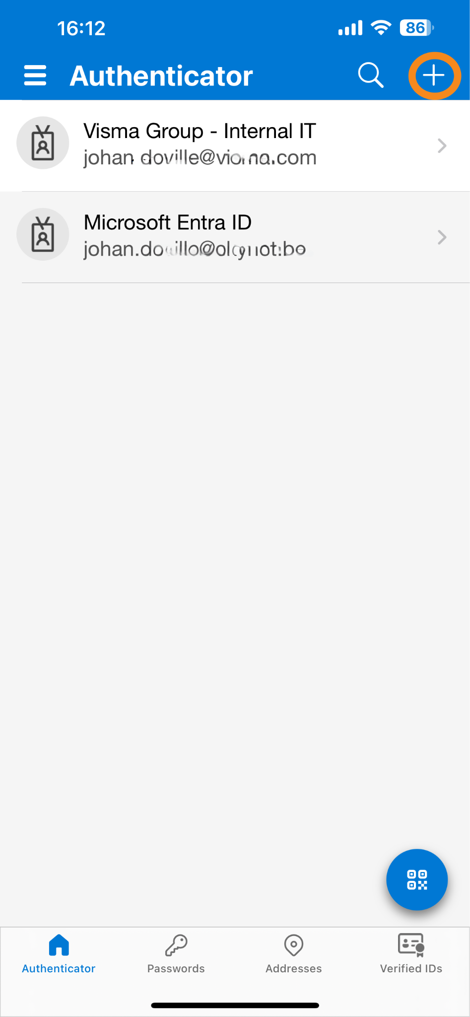

Step 7: Click on the option 'Other (Google, Facebook, etc.)
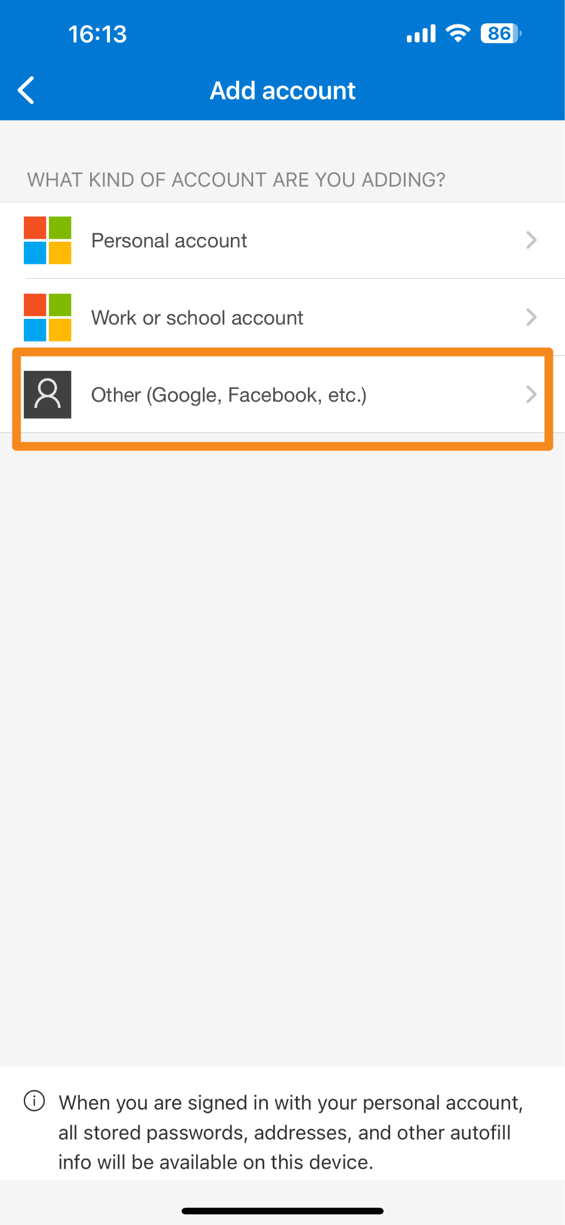

Step 8: scan the QR code on your screen*
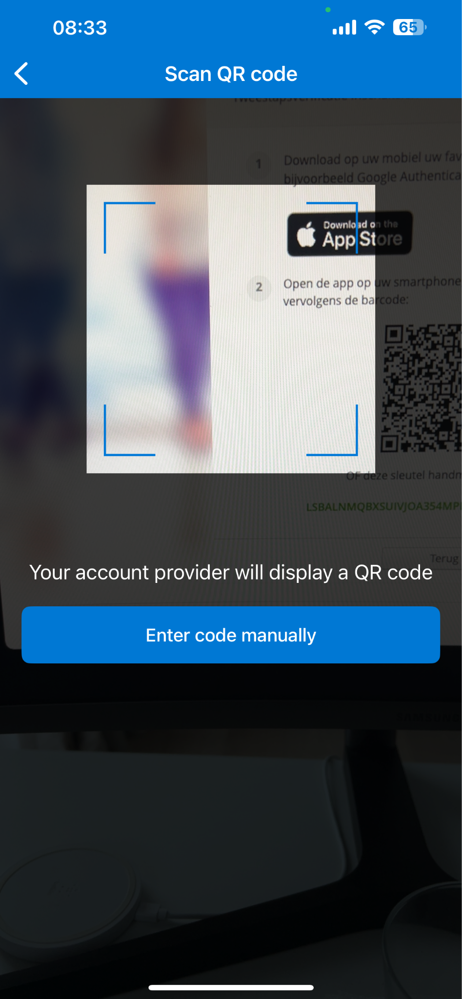 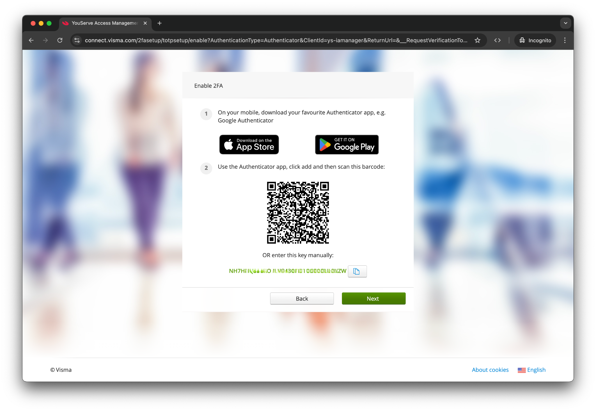
*Can't scan with your phone? Enter the manual code.

Step 9: The option has now been added to the Microsoft authenticator for your YouServe account
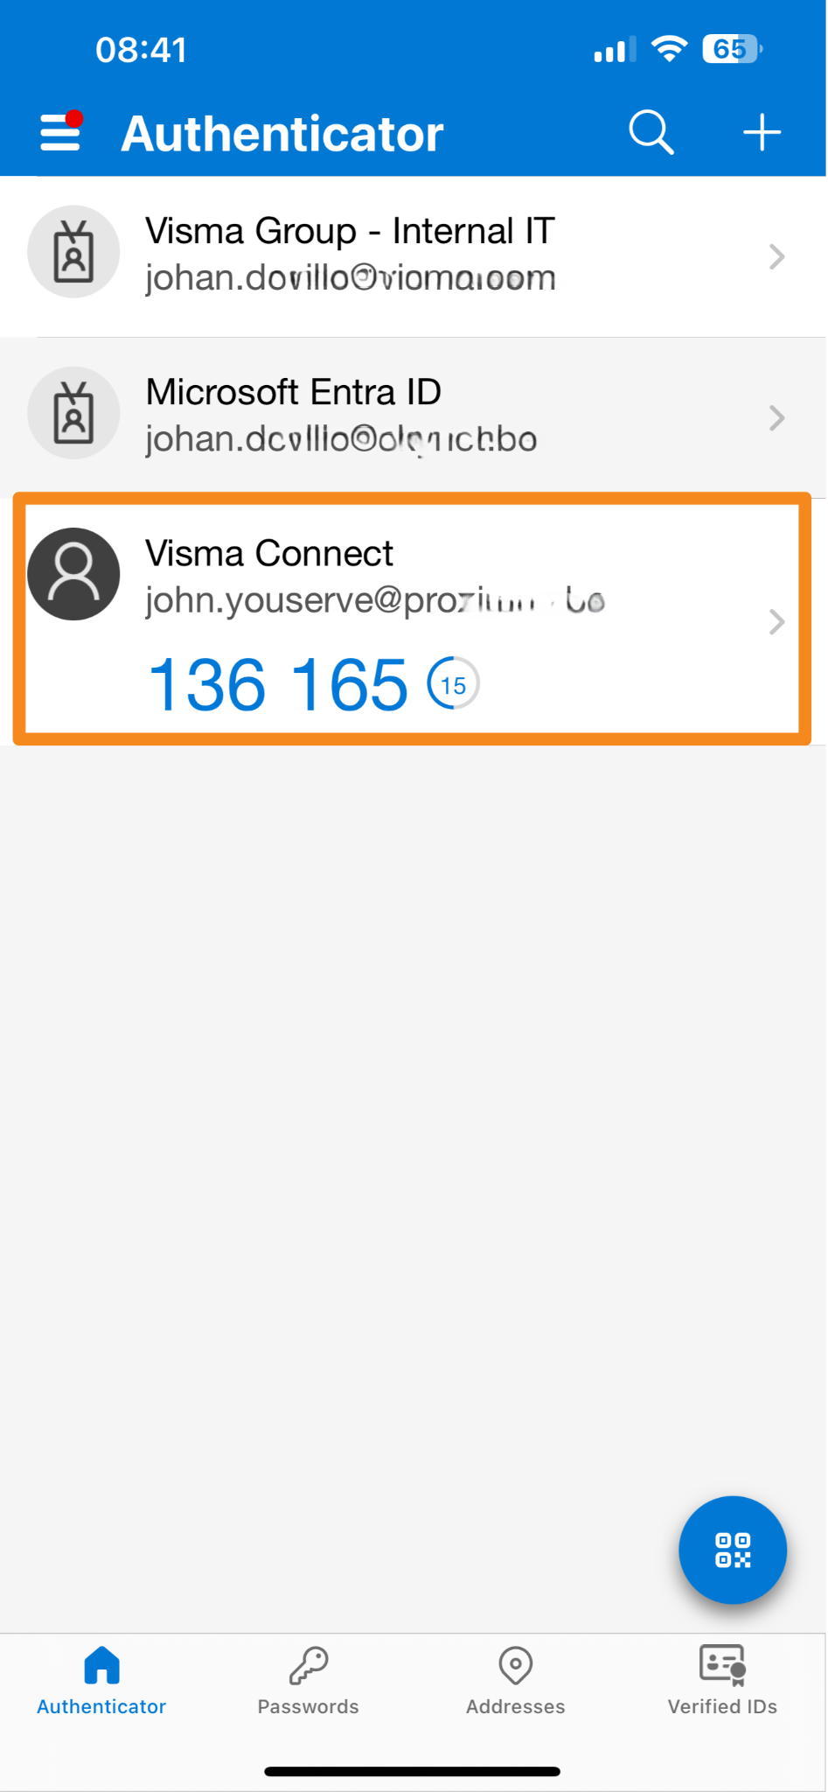
Continue to step 10

Google Authenticator
If you would like to use Google Authenticator, follow the steps below:

Step 5: Open the Google Authenticator app
Step 6: Click on the plus sign at the top right and select the option 'Scan QR code'
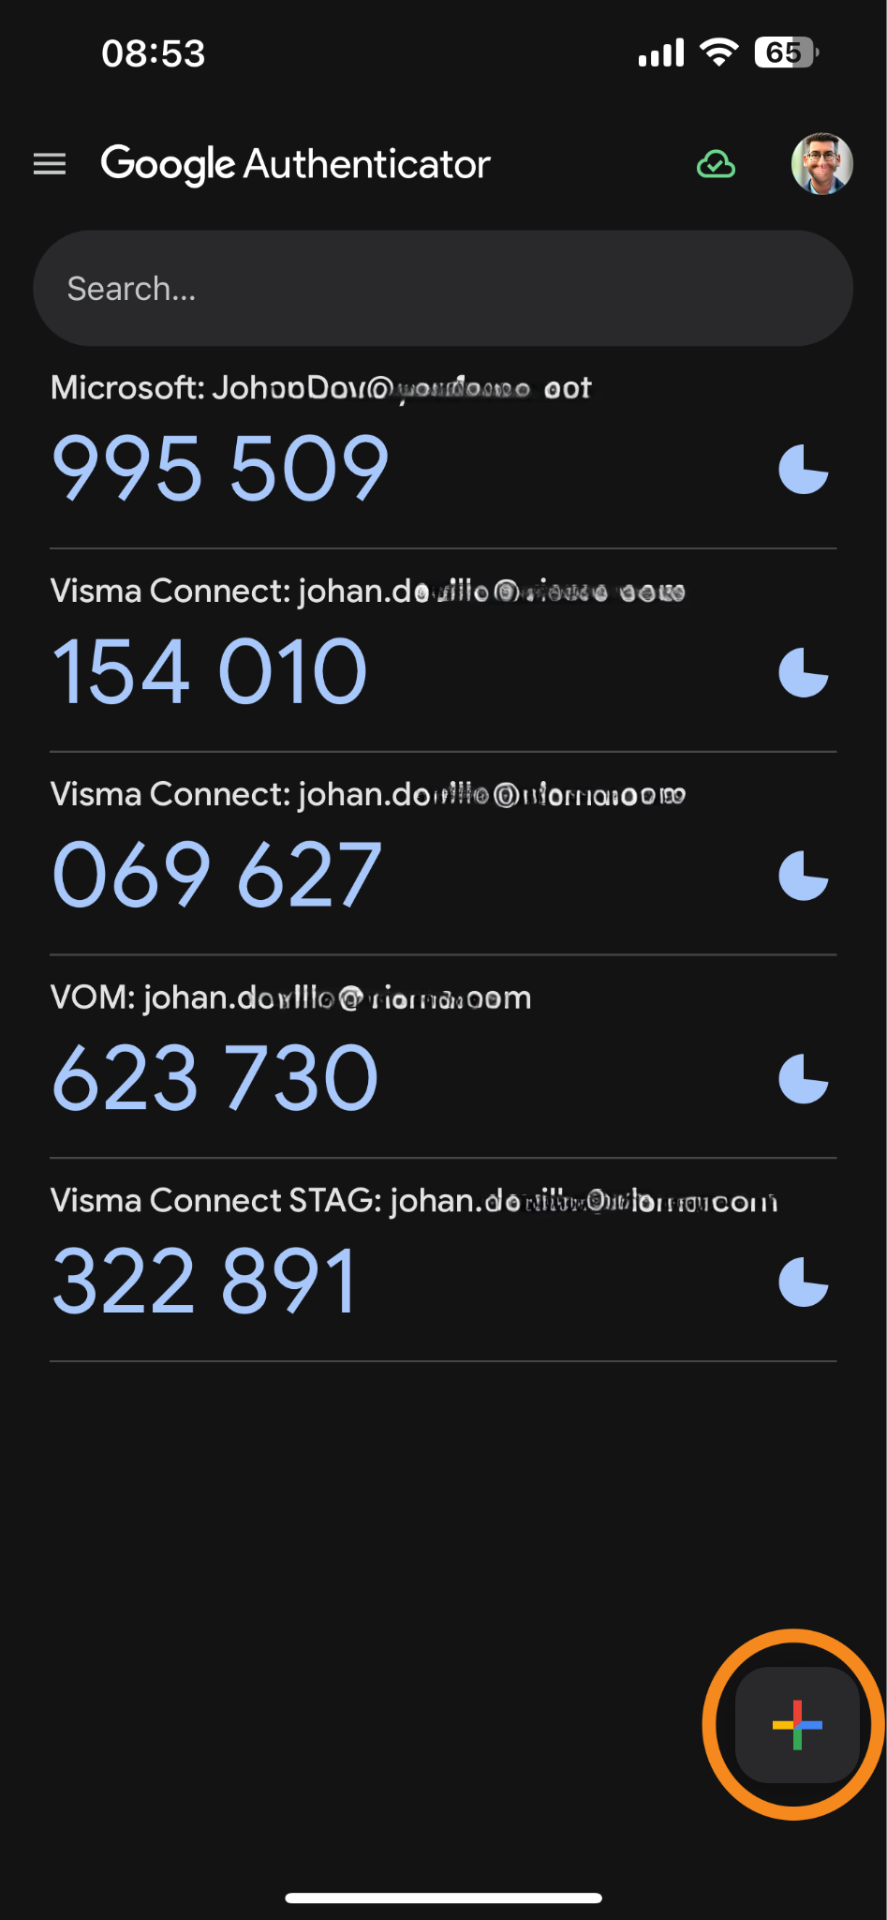

Step 7: scan the QR code on your screen*
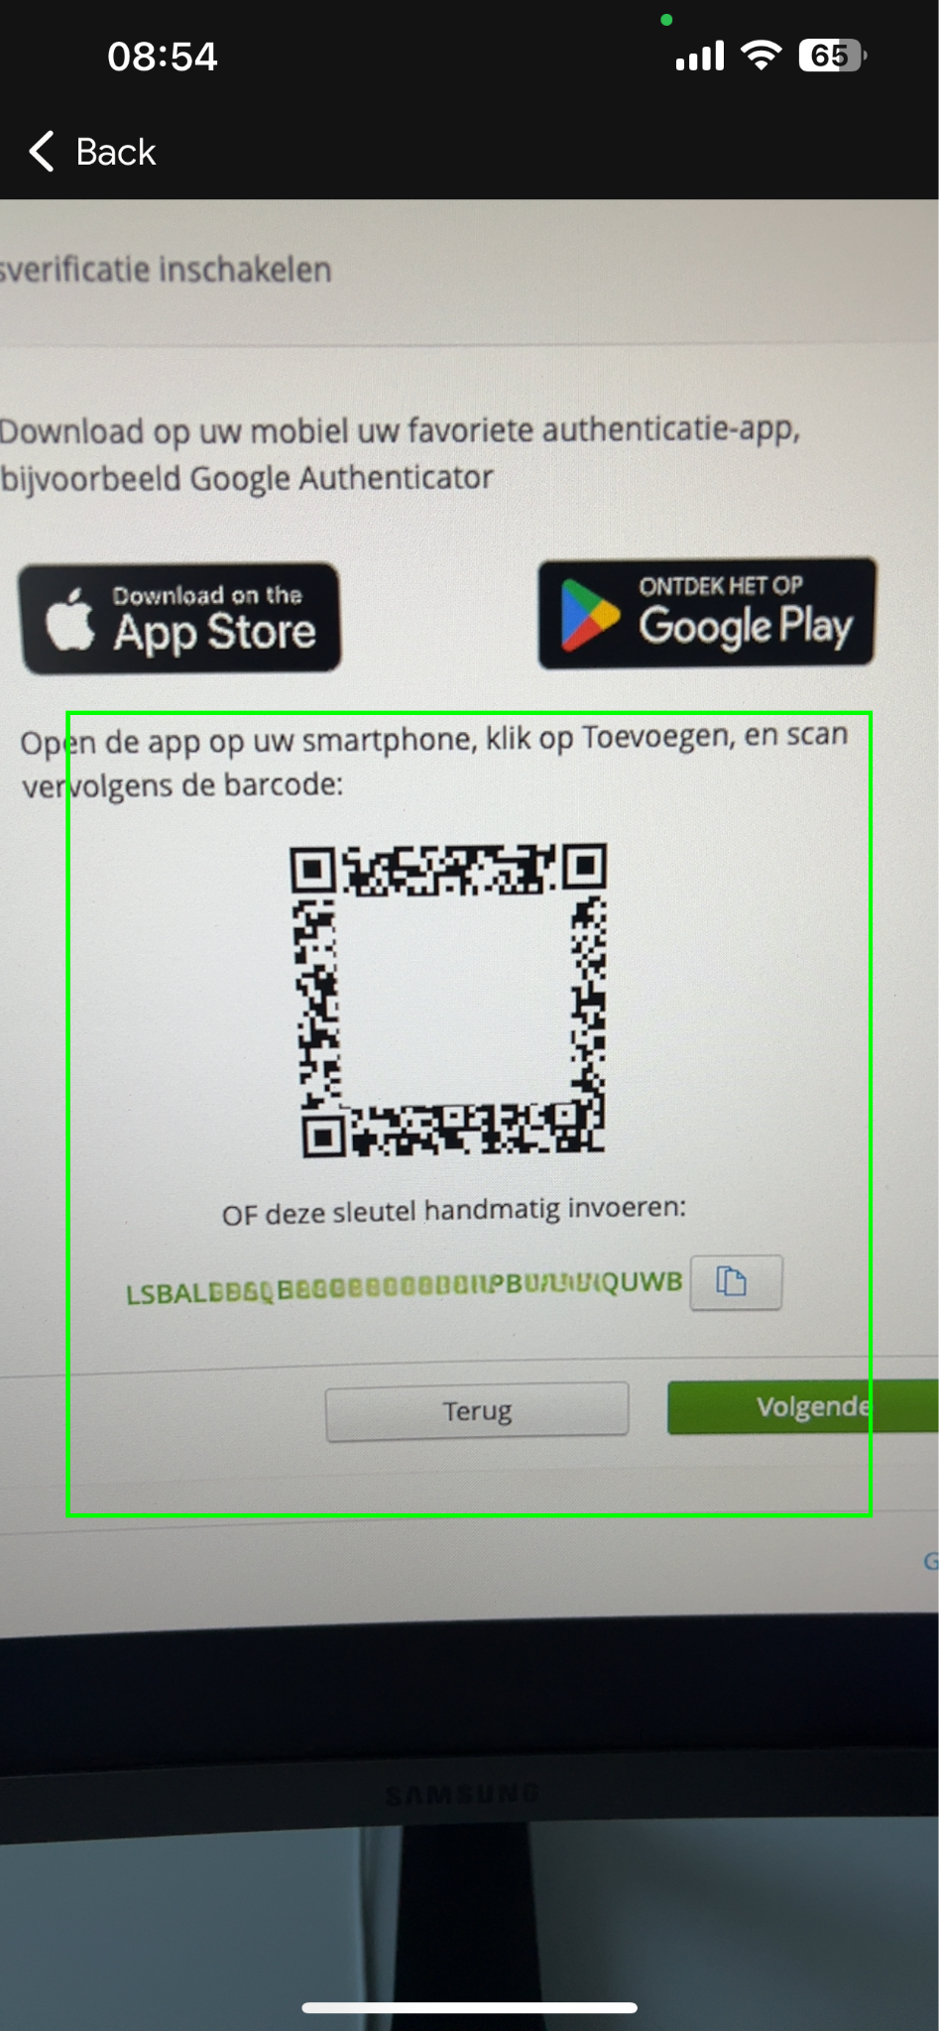
*Can't scan with your phone? Enter the manual code.
Step 8: The option is now added to the Google authenticator for your YouServe account. A new account is always added to the bottom of the list for verification
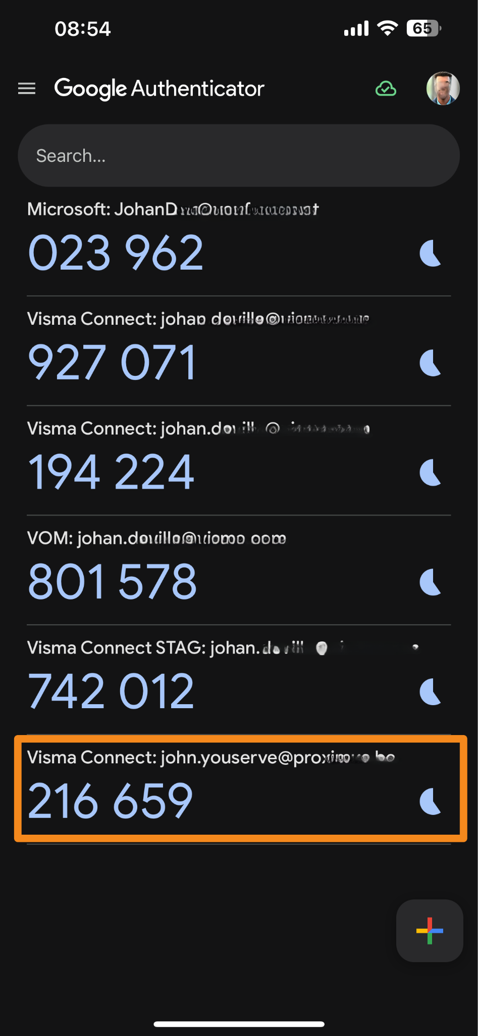
Continue to step 10
Step 10: Enter your phone number and click next
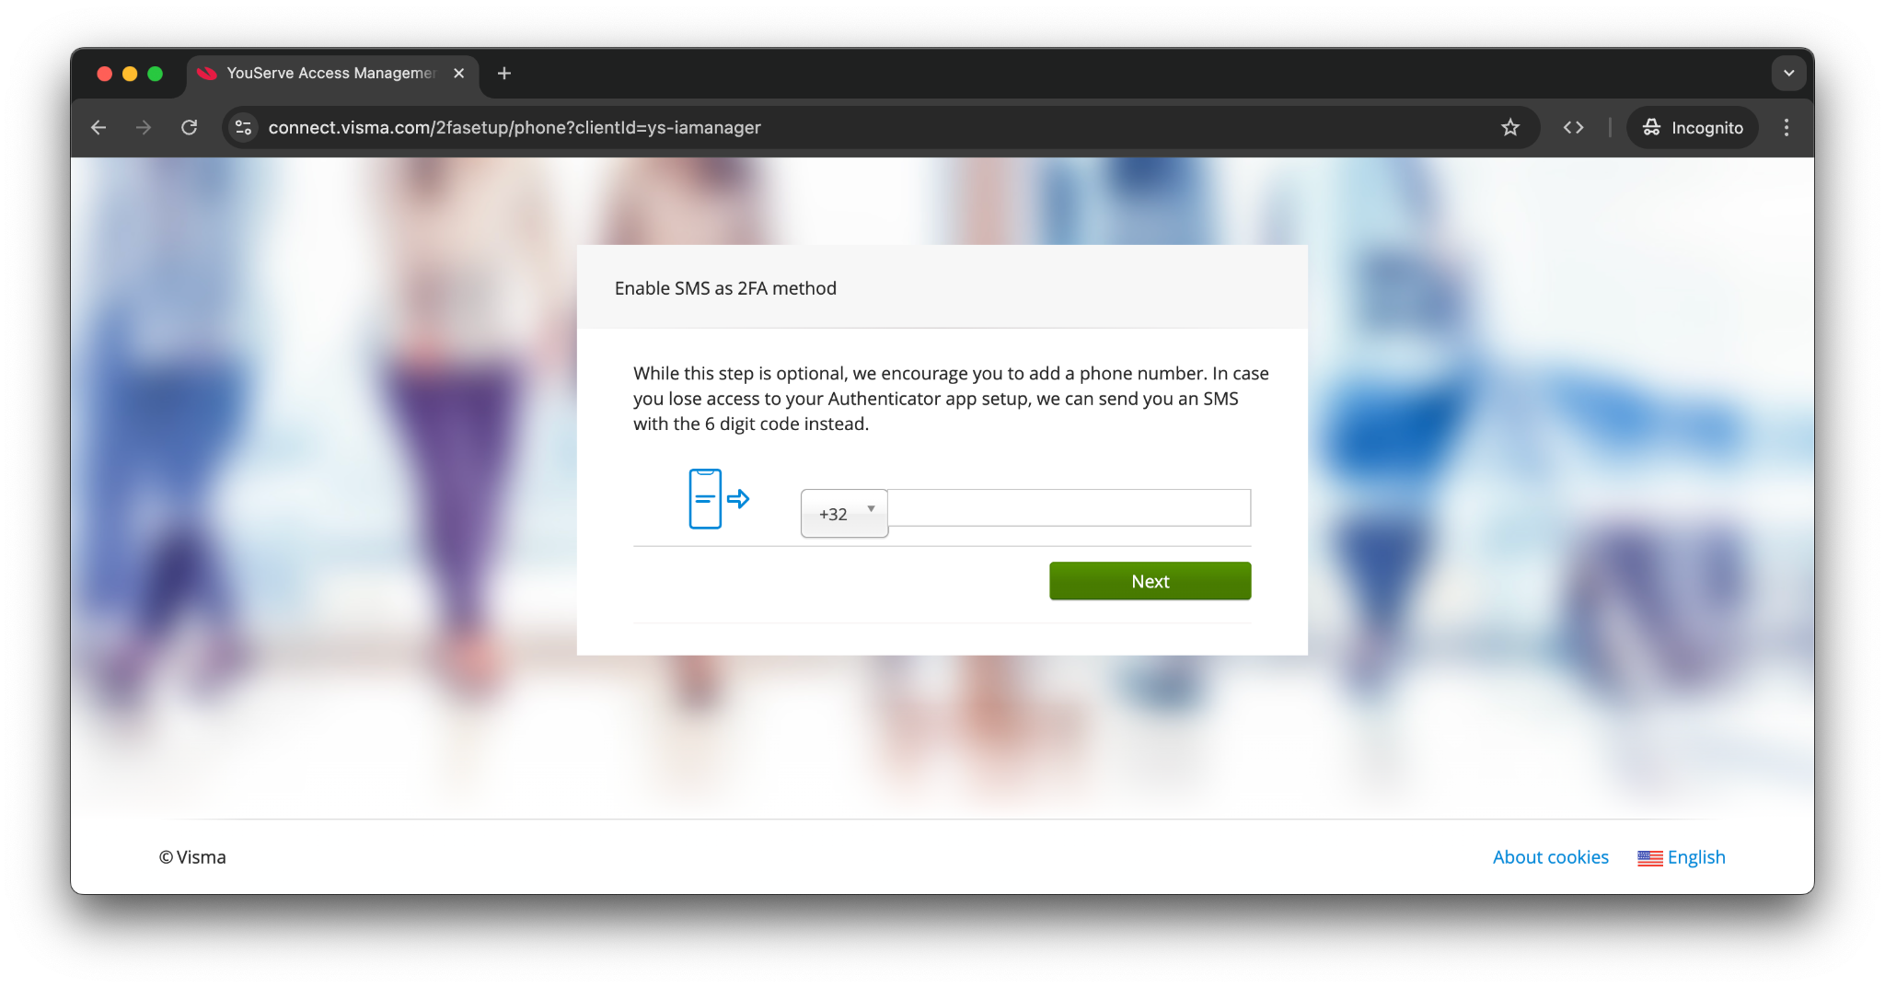
YouServe recommends adding your phone number as an option for Multi Factor Authentication. If you accidentally delete the app or get a new phone, you can still verify yourself by receiving a text message on your phone number.

Step 11: Enter the verification code you received in a text message to the telephone number you just provided and click next
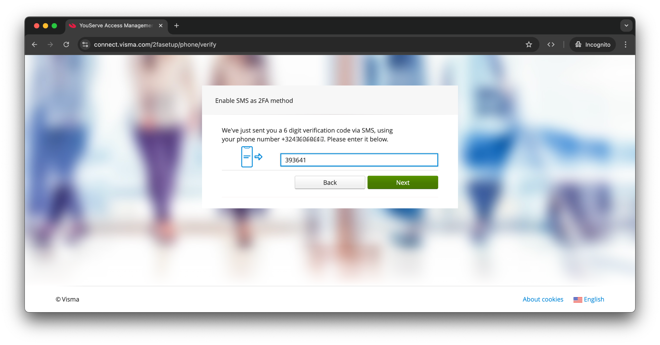

Step 12: Save the backup code in a place where you won't lose it easily. Check the box and click next
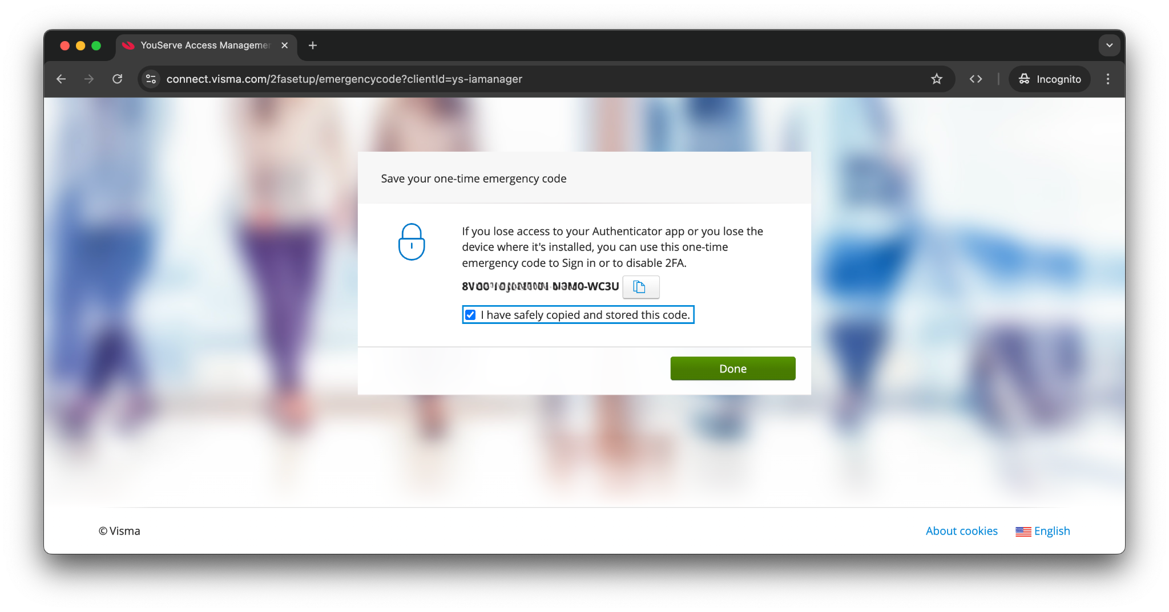
Keep this backup code safe. You can use this code as a second factor when your phone is forgotten, lost, broken or stolen. This way you can also log in to YouServe without a phone!

Step 13: Success! You have set up your multi-factor authentication. Click on ‘Done’ and you will be logged in to My YouServe. From now on you can log in via my.youserve.nl.
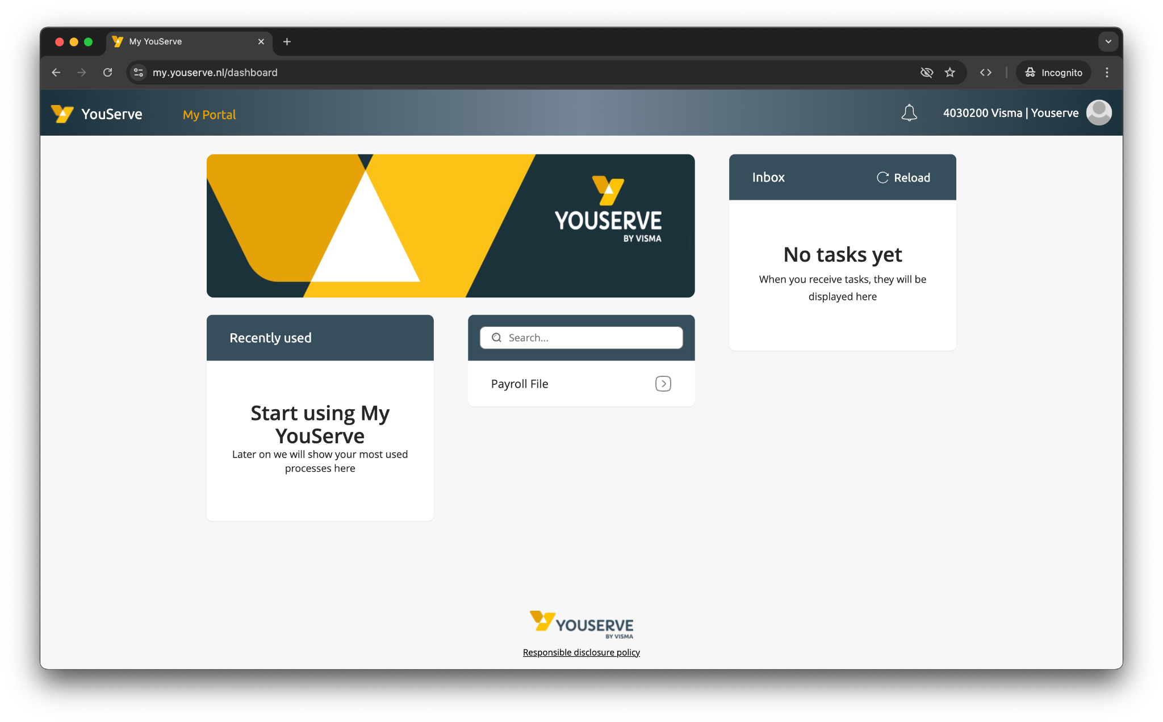

E-mail notifications
When setting up two-factor authentication, phone number for SMS authentication and later for setting up the recovery email address you will receive email notifications. The content of these email notifications will differ depending on the changes you have made or when the Connect system detects that you are logging in from a different device or country.

Below are some examples.

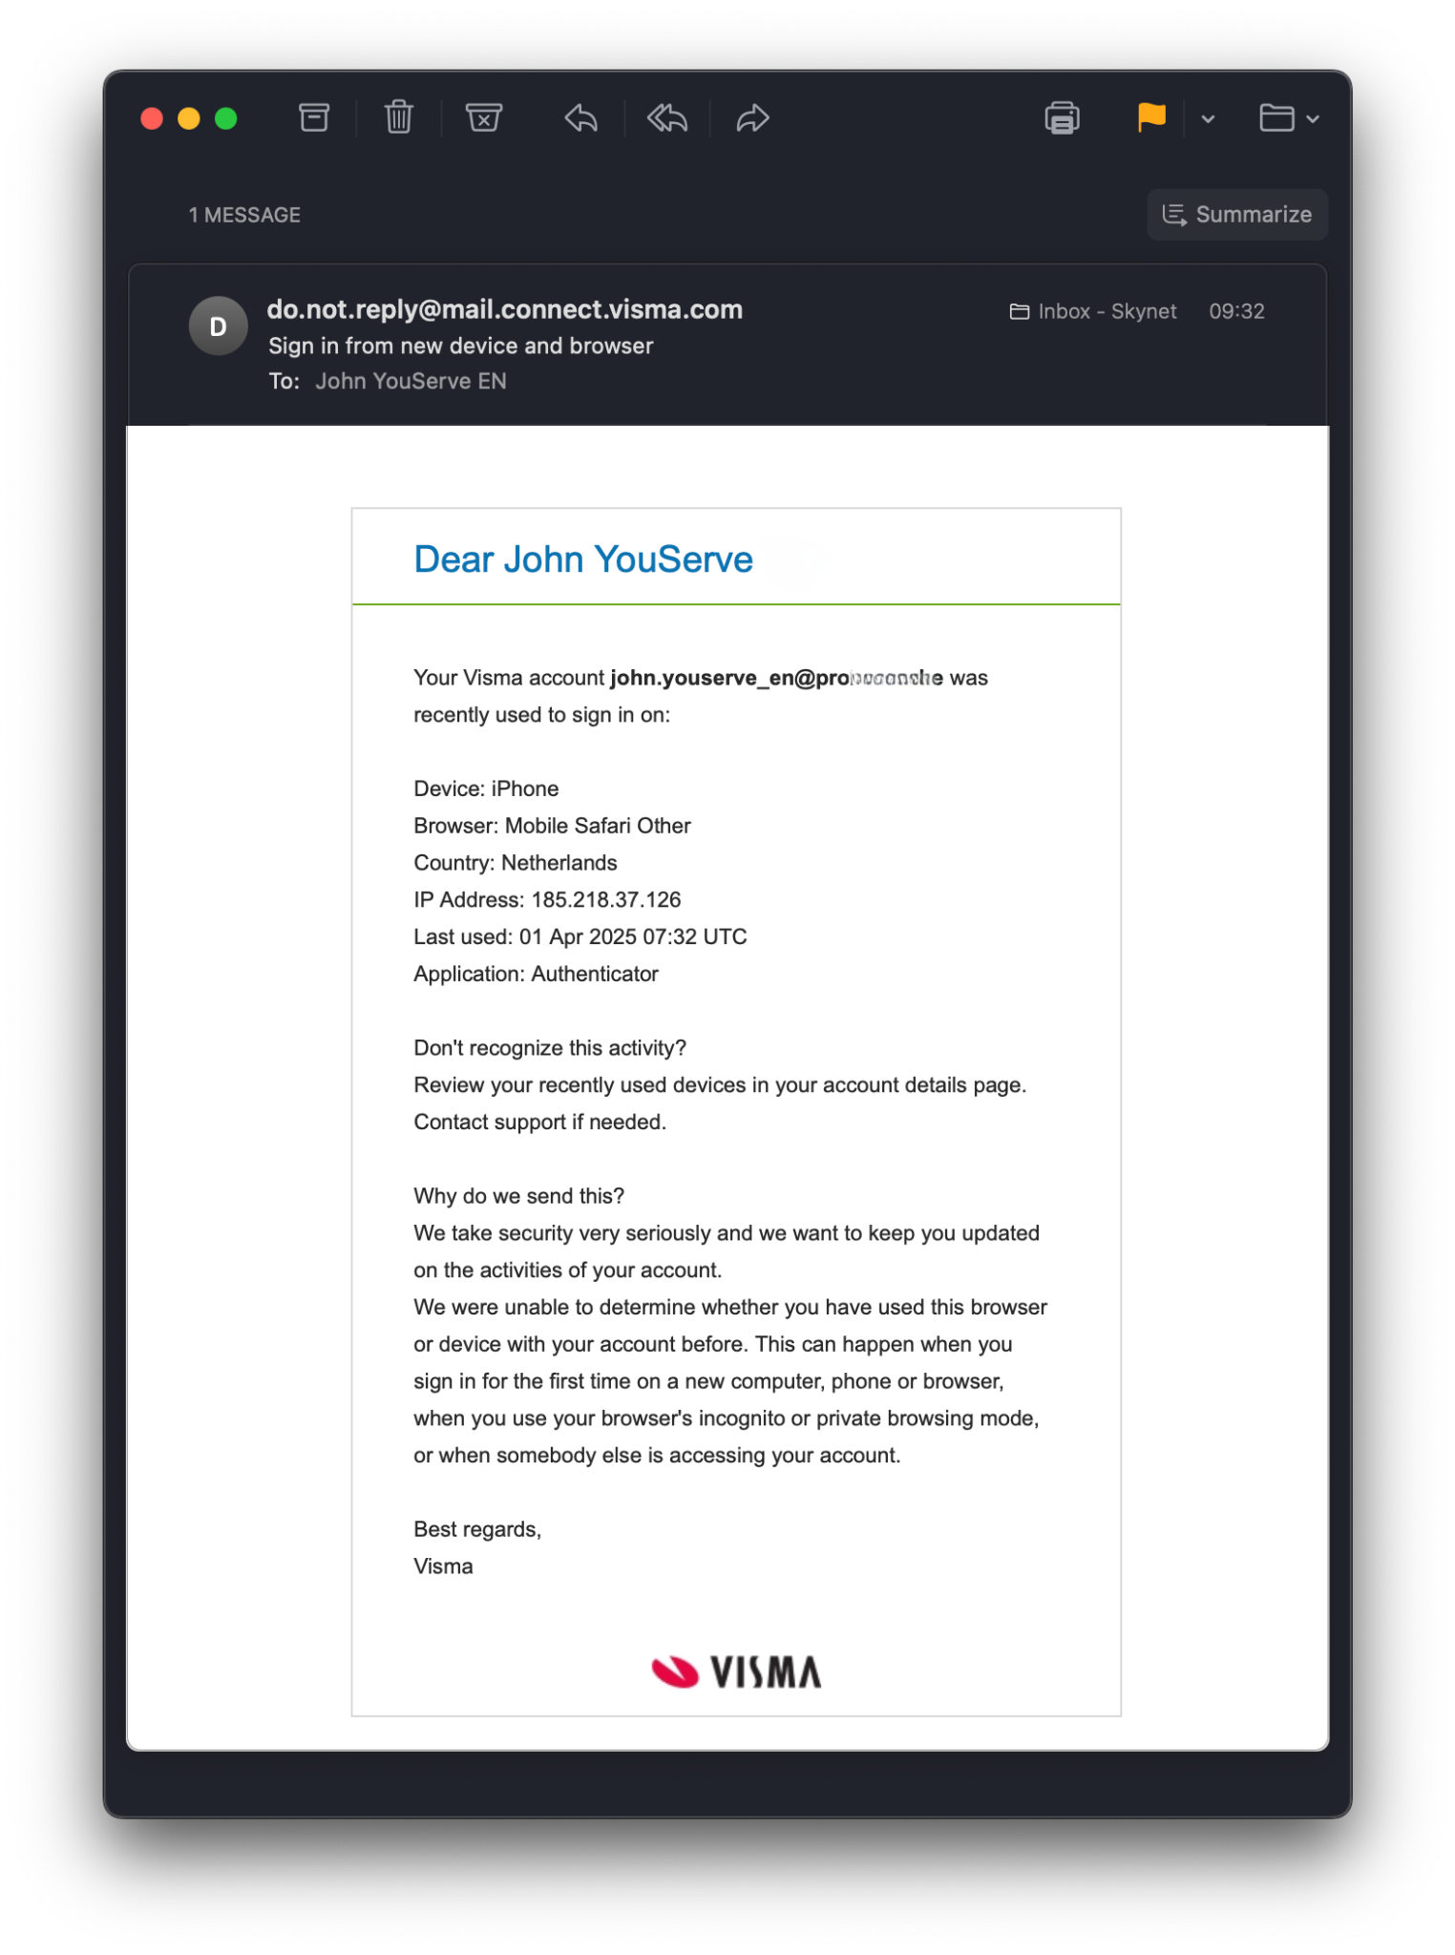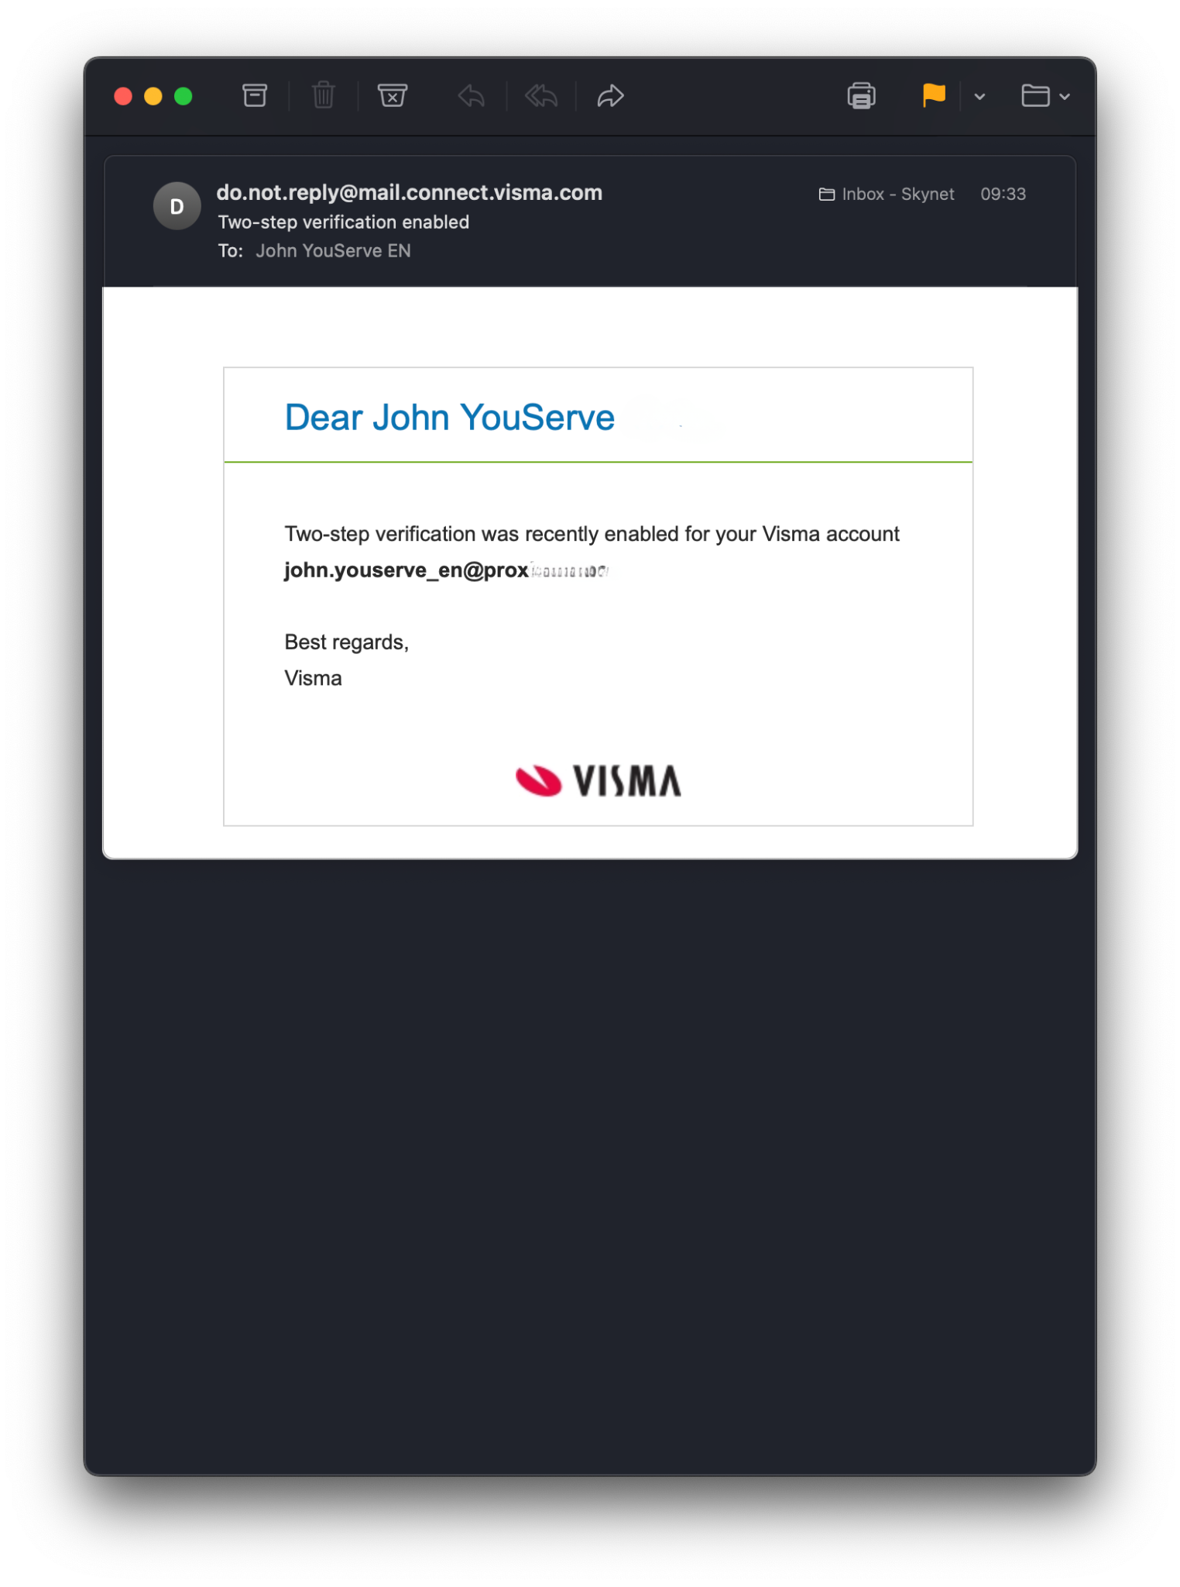
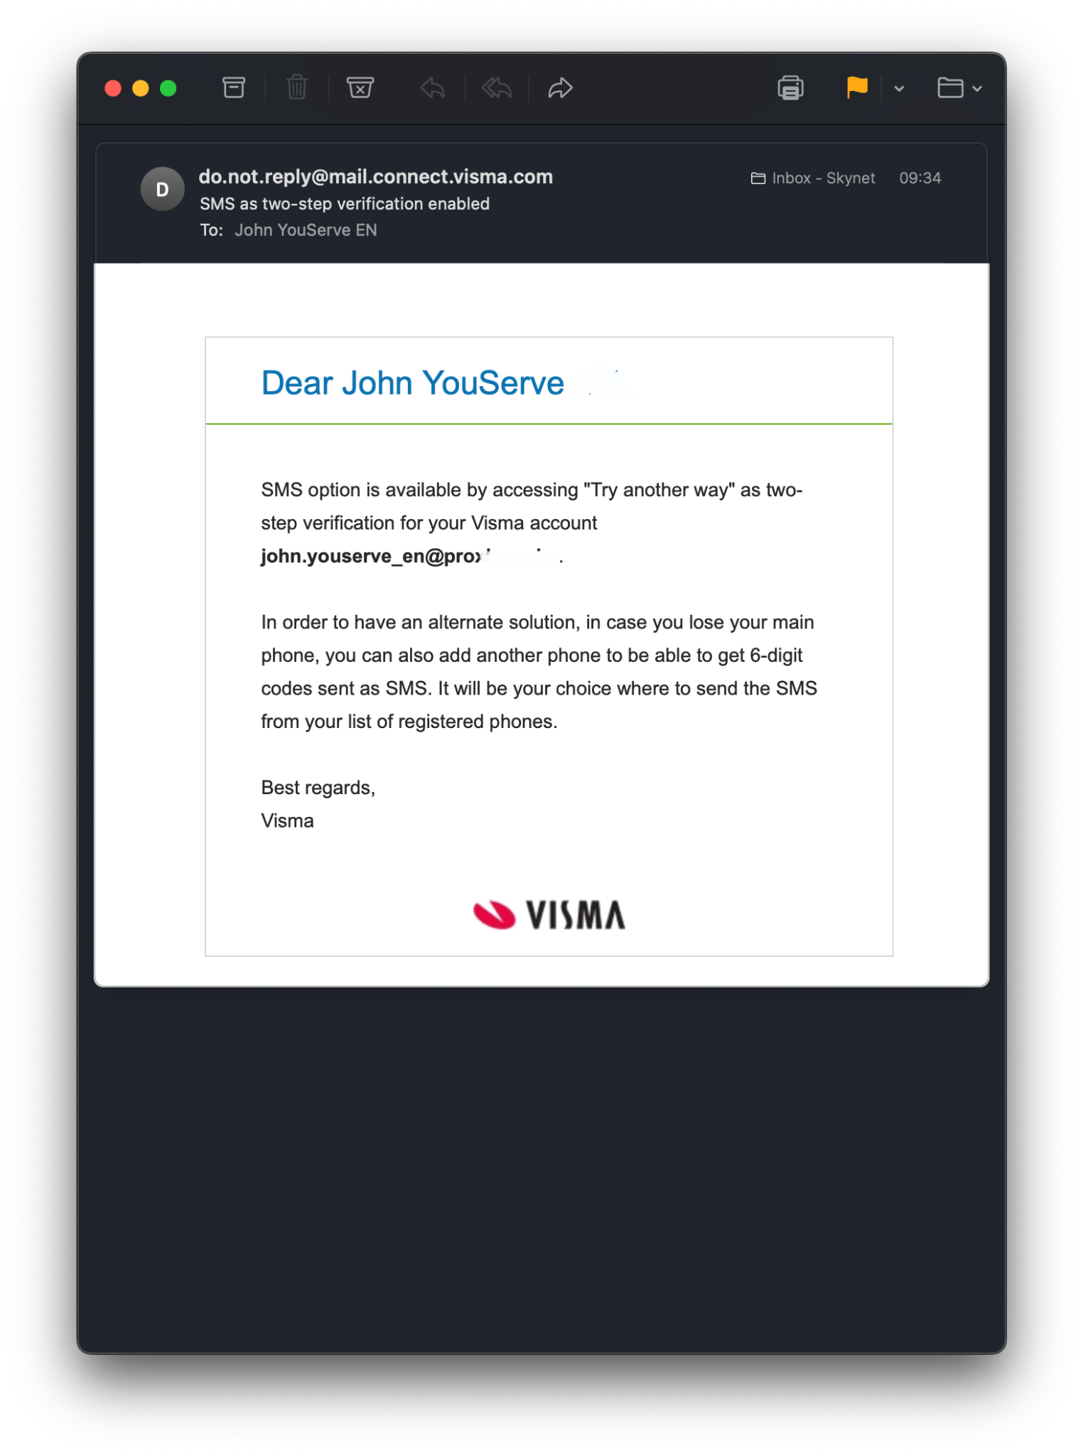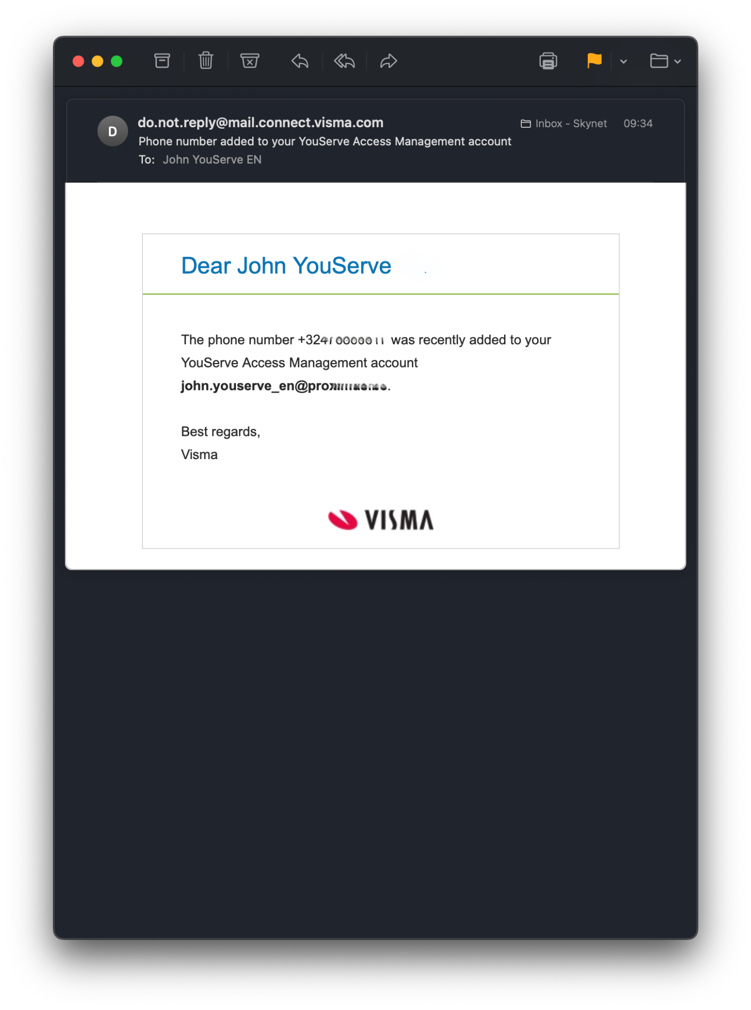

Personal settings
Personal Settings offers a variety of features aimed at customizing and securing your account. These features, along with many others, allow you to customize your online experience while ensuring that your account remains safe and secure.

You can view and edit your account information. This includes personal information such as your name, email addresses, and profile photo, so you can keep your profile up to date and reflect your identity. The password change functionality is crucial to maintaining the security of your account. You can also change your authentication app (2FA) through the Personal settings page.

Session History provides insight into active login sessions, so you can monitor account activity and identify suspicious or unauthorized access. You can log out of any session if necessary.

Device History shows a list of your devices that have accessed your account, so you can manage trusted devices and revoke access to unknown devices.

In My YouServe, click on your profile picture and select 'personal settings' to navigate to your account settings or navigate directly to https://accountsettings.connect.visma.com/

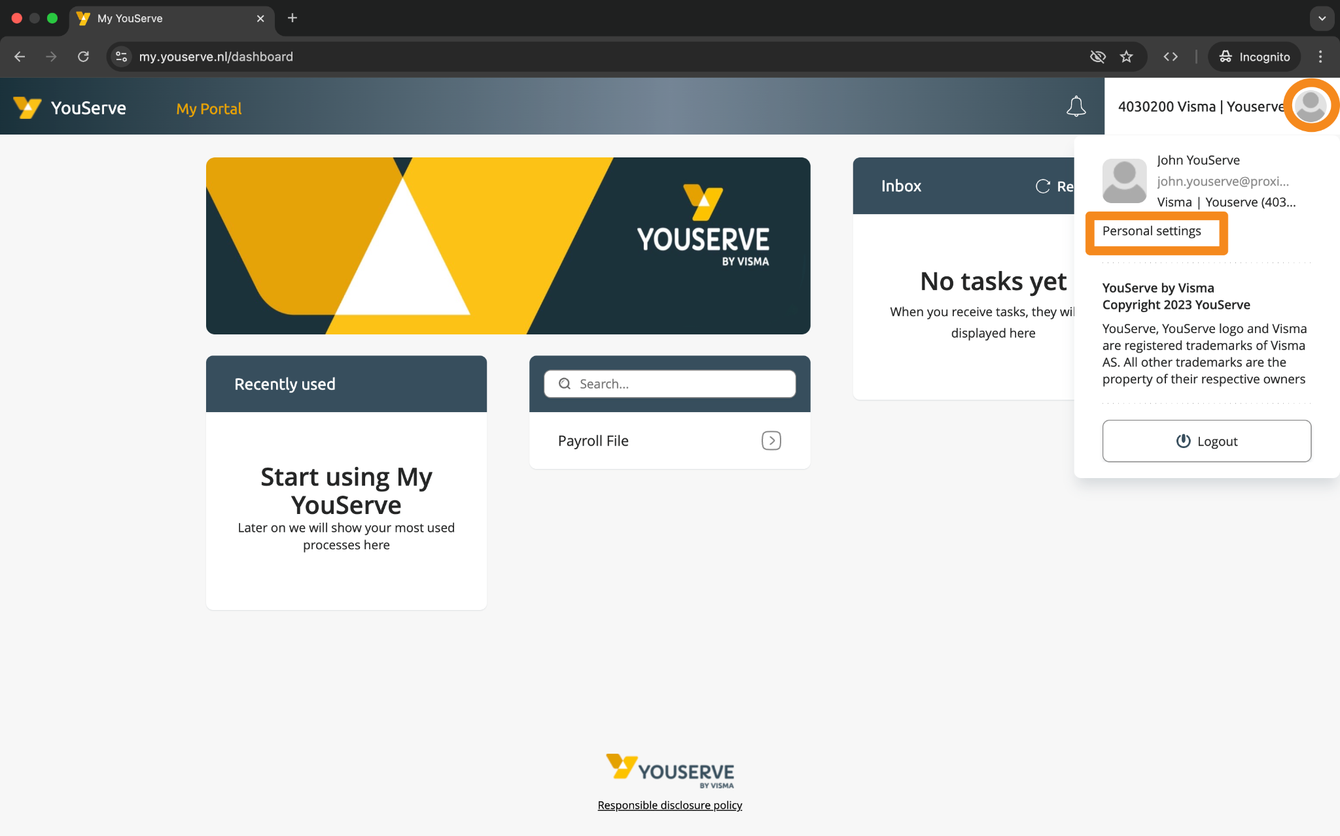

Problems logging in

Forgot your password?
Are you logging in and you don't remember your password? You can easily create a new password by clicking on 'Forgot your password?'.
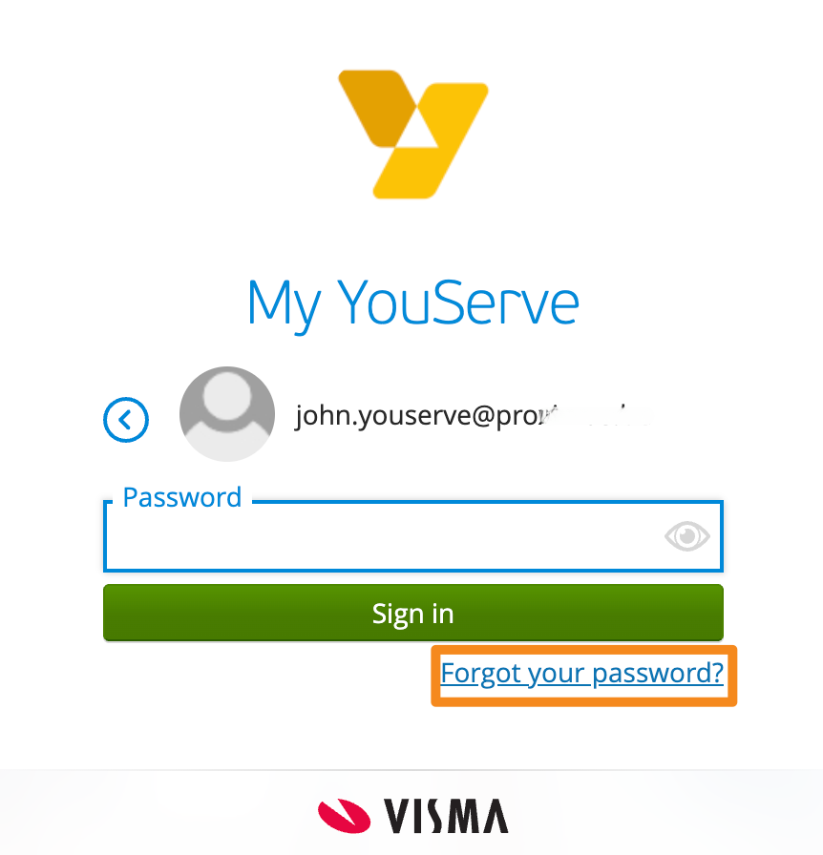

You will then be given the option to reset your password or use a one-time link to log in and enter your YouServe username as your email address.
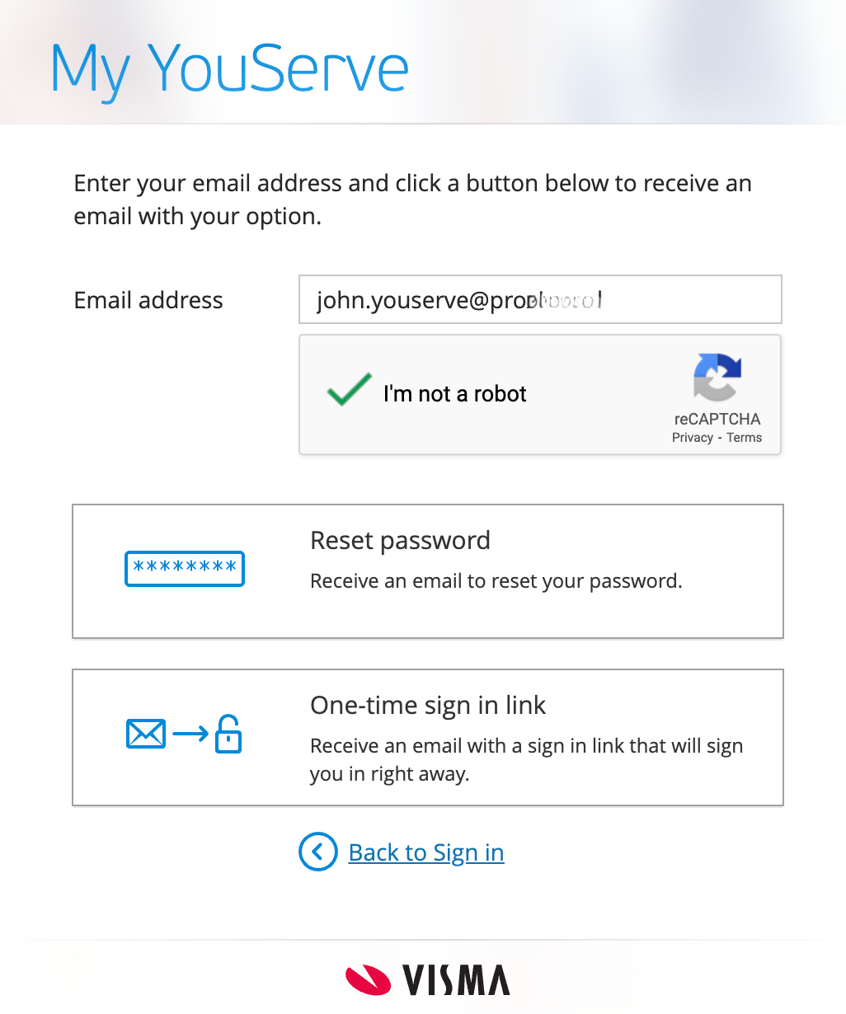

Reset password
With password reset you will receive an email with a link. If you click on this link, you can change your password.
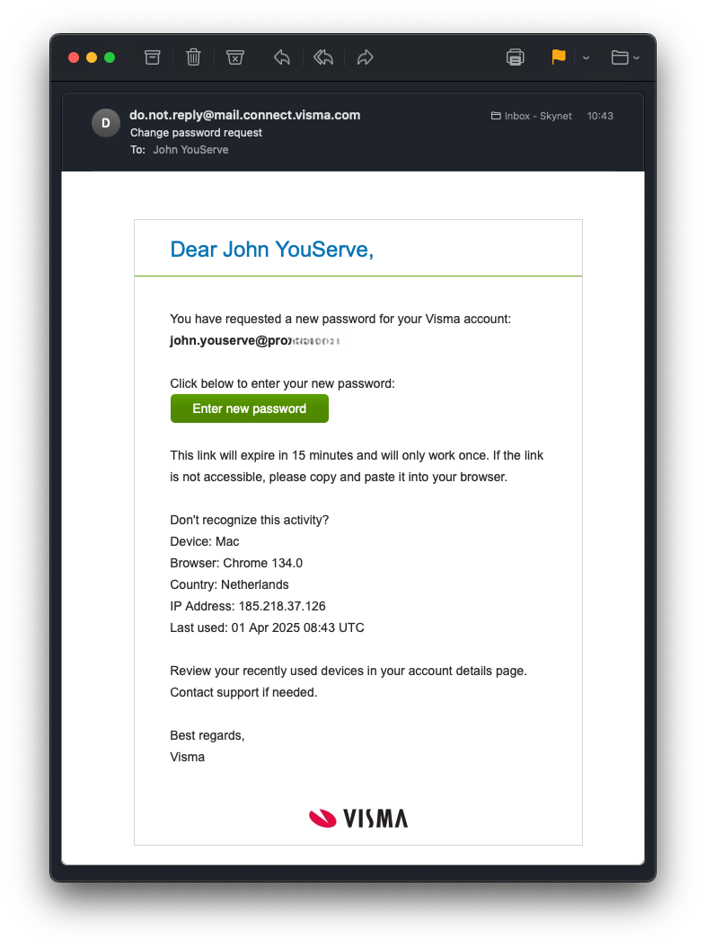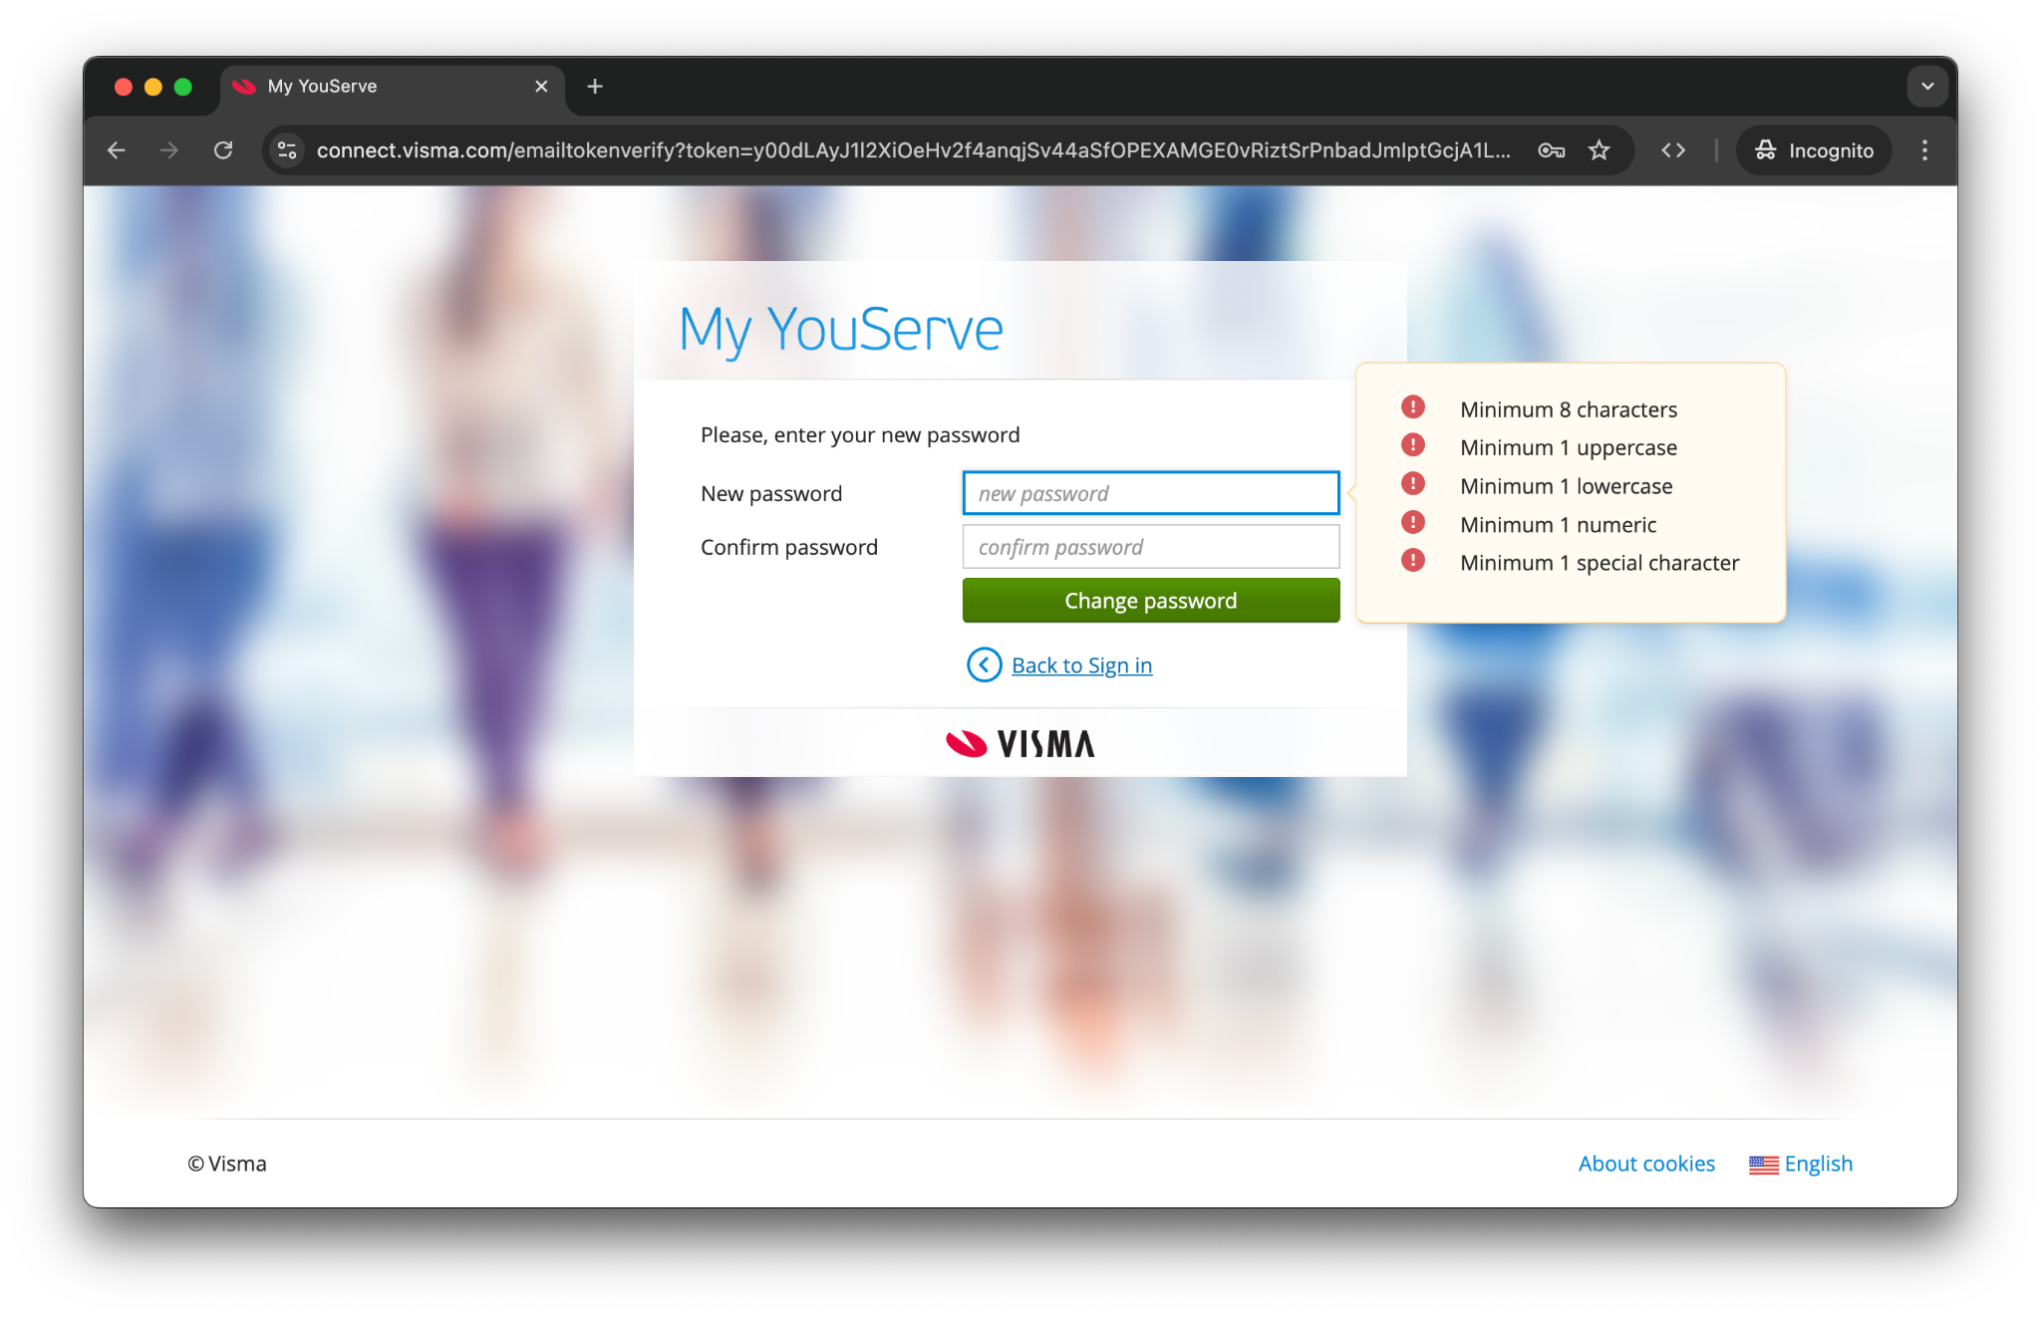

One time sign-in link
With a one-time link, you can log in without having to change your password. Check your email and click on the link. You can then enter the code for two-factor authentication or accept the push notification.
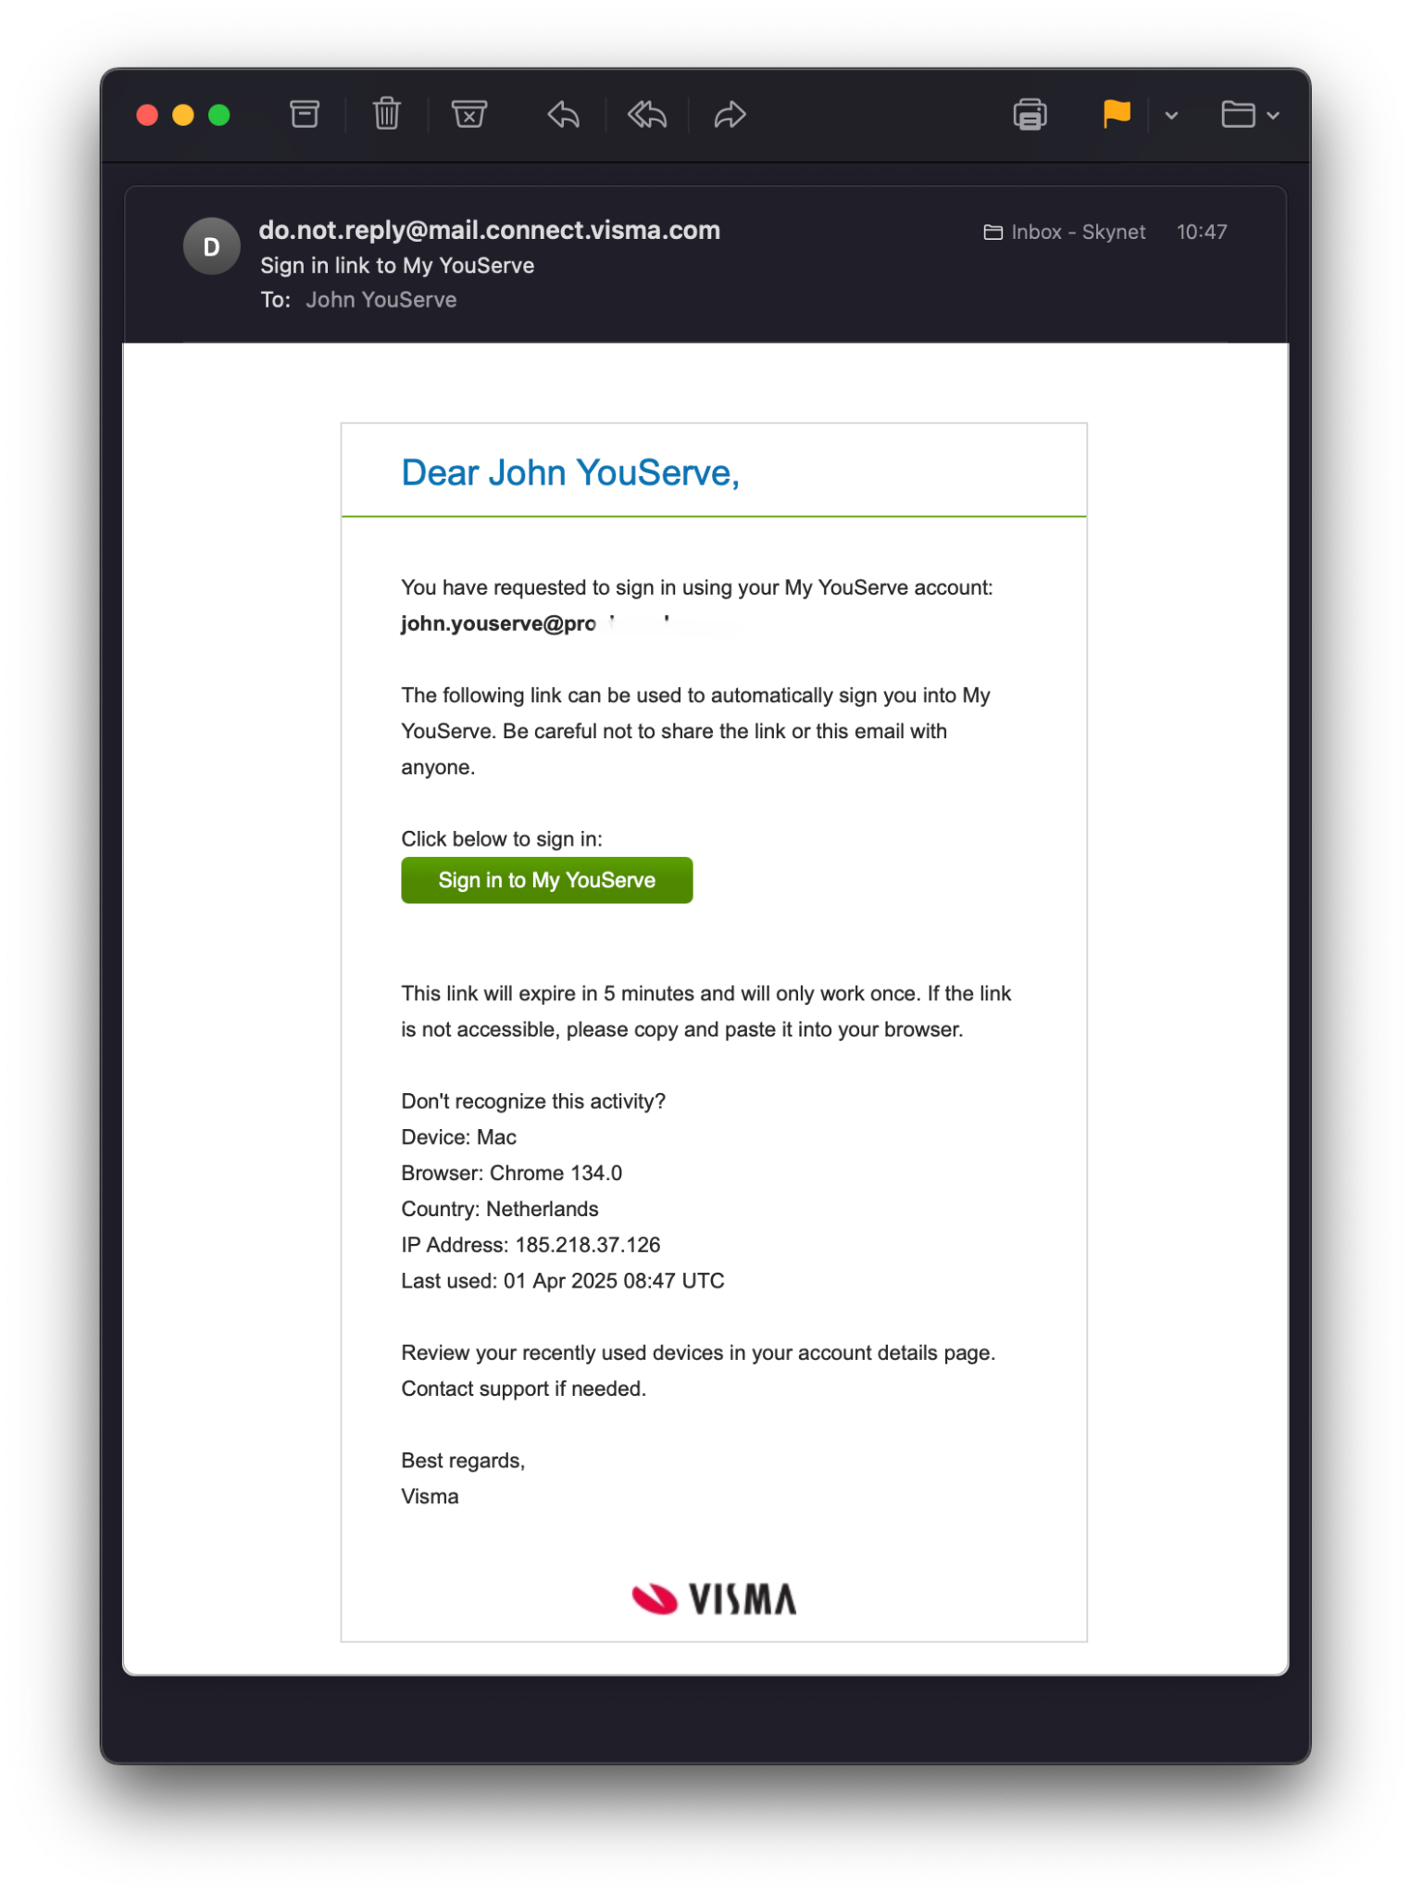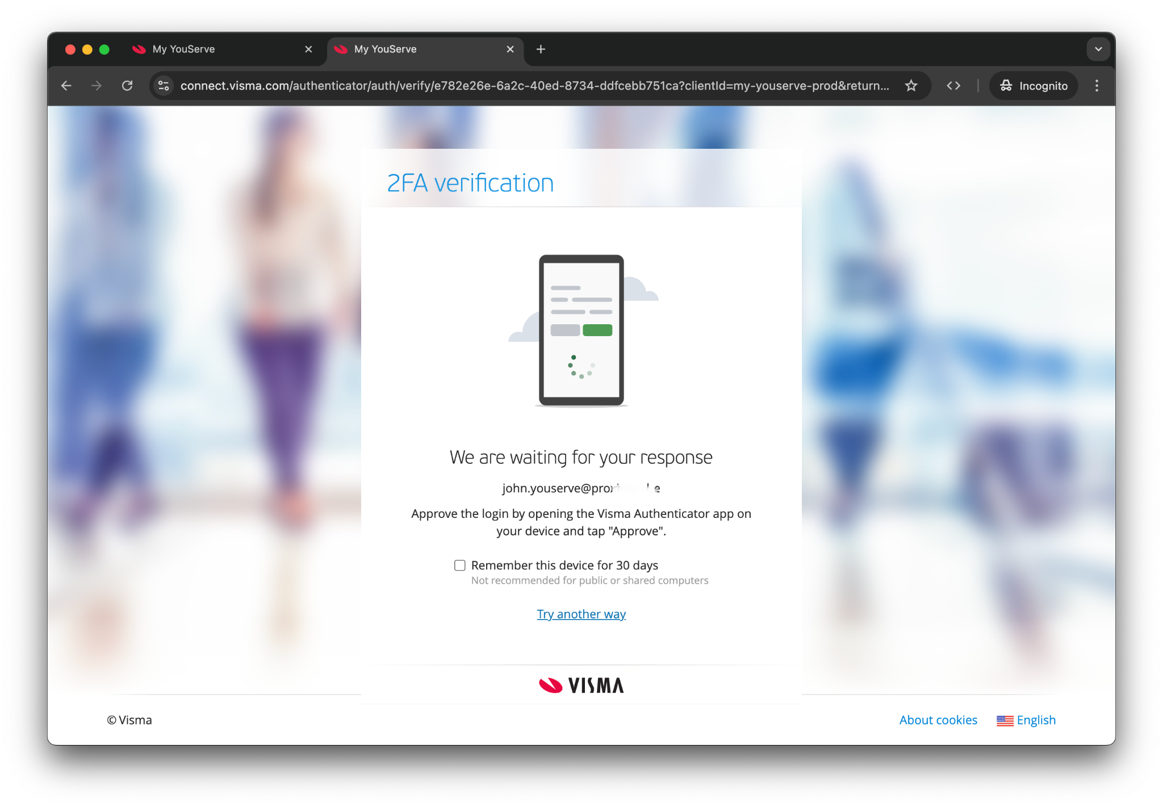

Change Authenticator App (2FA)
If you want to change your authenticator app, you can do this via your Personal Settings. To do this, you must first successfully log in using the authenticator app that is currently linked to your account. If you no longer have access to it, see No access to your authenticator app.

Log in to your account
Go to www.youserve.nl/inloggen/ and choose ‘Inloggen My Youserve’. Then log in with your username, password, and authenticator app.

Go to the ‘Personal Settings’ page
In My YouServe, click on your profile picture and select ‘Personal Settings’ to navigate to the page with your account details.

Please note: this page will open in a new tab.

Change your authenticator app
In your Personal Settings, scroll down until you reach ‘Password & 2FA’. There you will find the option ‘Authenticator App’. Click on ‘Add another device’.

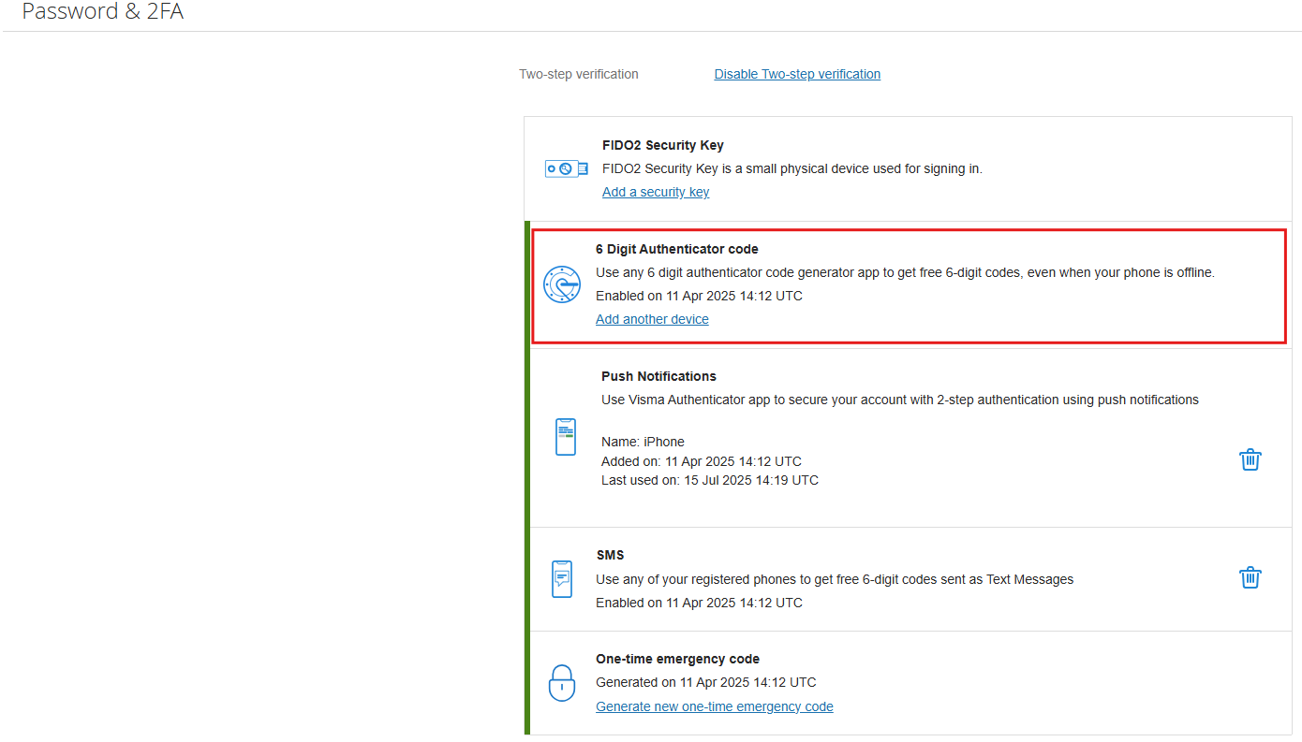

You will be asked to identify yourself again via your current authenticator app. Enter the six-digit code displayed in the authenticator app and click ‘Next’.

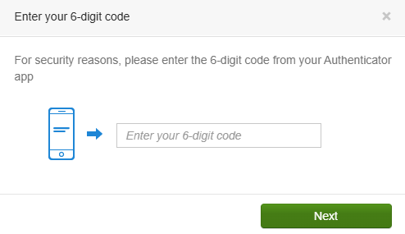

Please note: the code is time-sensitive and may have expired by the time you enter it. Keep this in mind.

Link the new authenticator app
Next, open the authenticator app on the phone you want to use from now on for 2FA. You can choose to scan the displayed QR code using your authenticator app or to manually enter the displayed code.

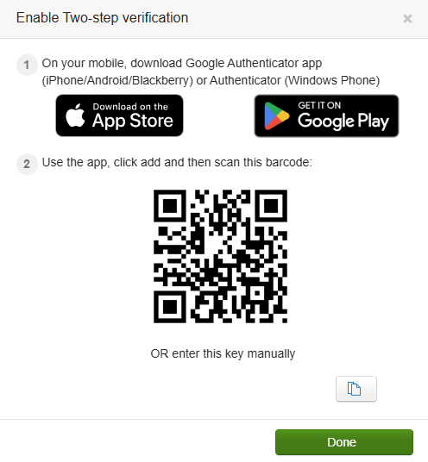

Click ‘Done’ to complete the process. Your new authenticator app is now linked.

No access to your authenticator app
If you don't have access to the authenticator app, you can use the backup code so you can still log in.

What is the backup code?
The backup code is a one-time code that can be used as two-factor authentication. This is nice to have as a backup for when you have forgotten, lost or replaced your phone, for example.

How do you get a backup code?
When you activate your account, you will receive a backup code. If you do not have access to the device for two-factor authentication during login, you can use this backup code. It is important that you have it saved and available. If you no longer have it, but can still log in, you can request a new backup code yourself in the Personal Settings.
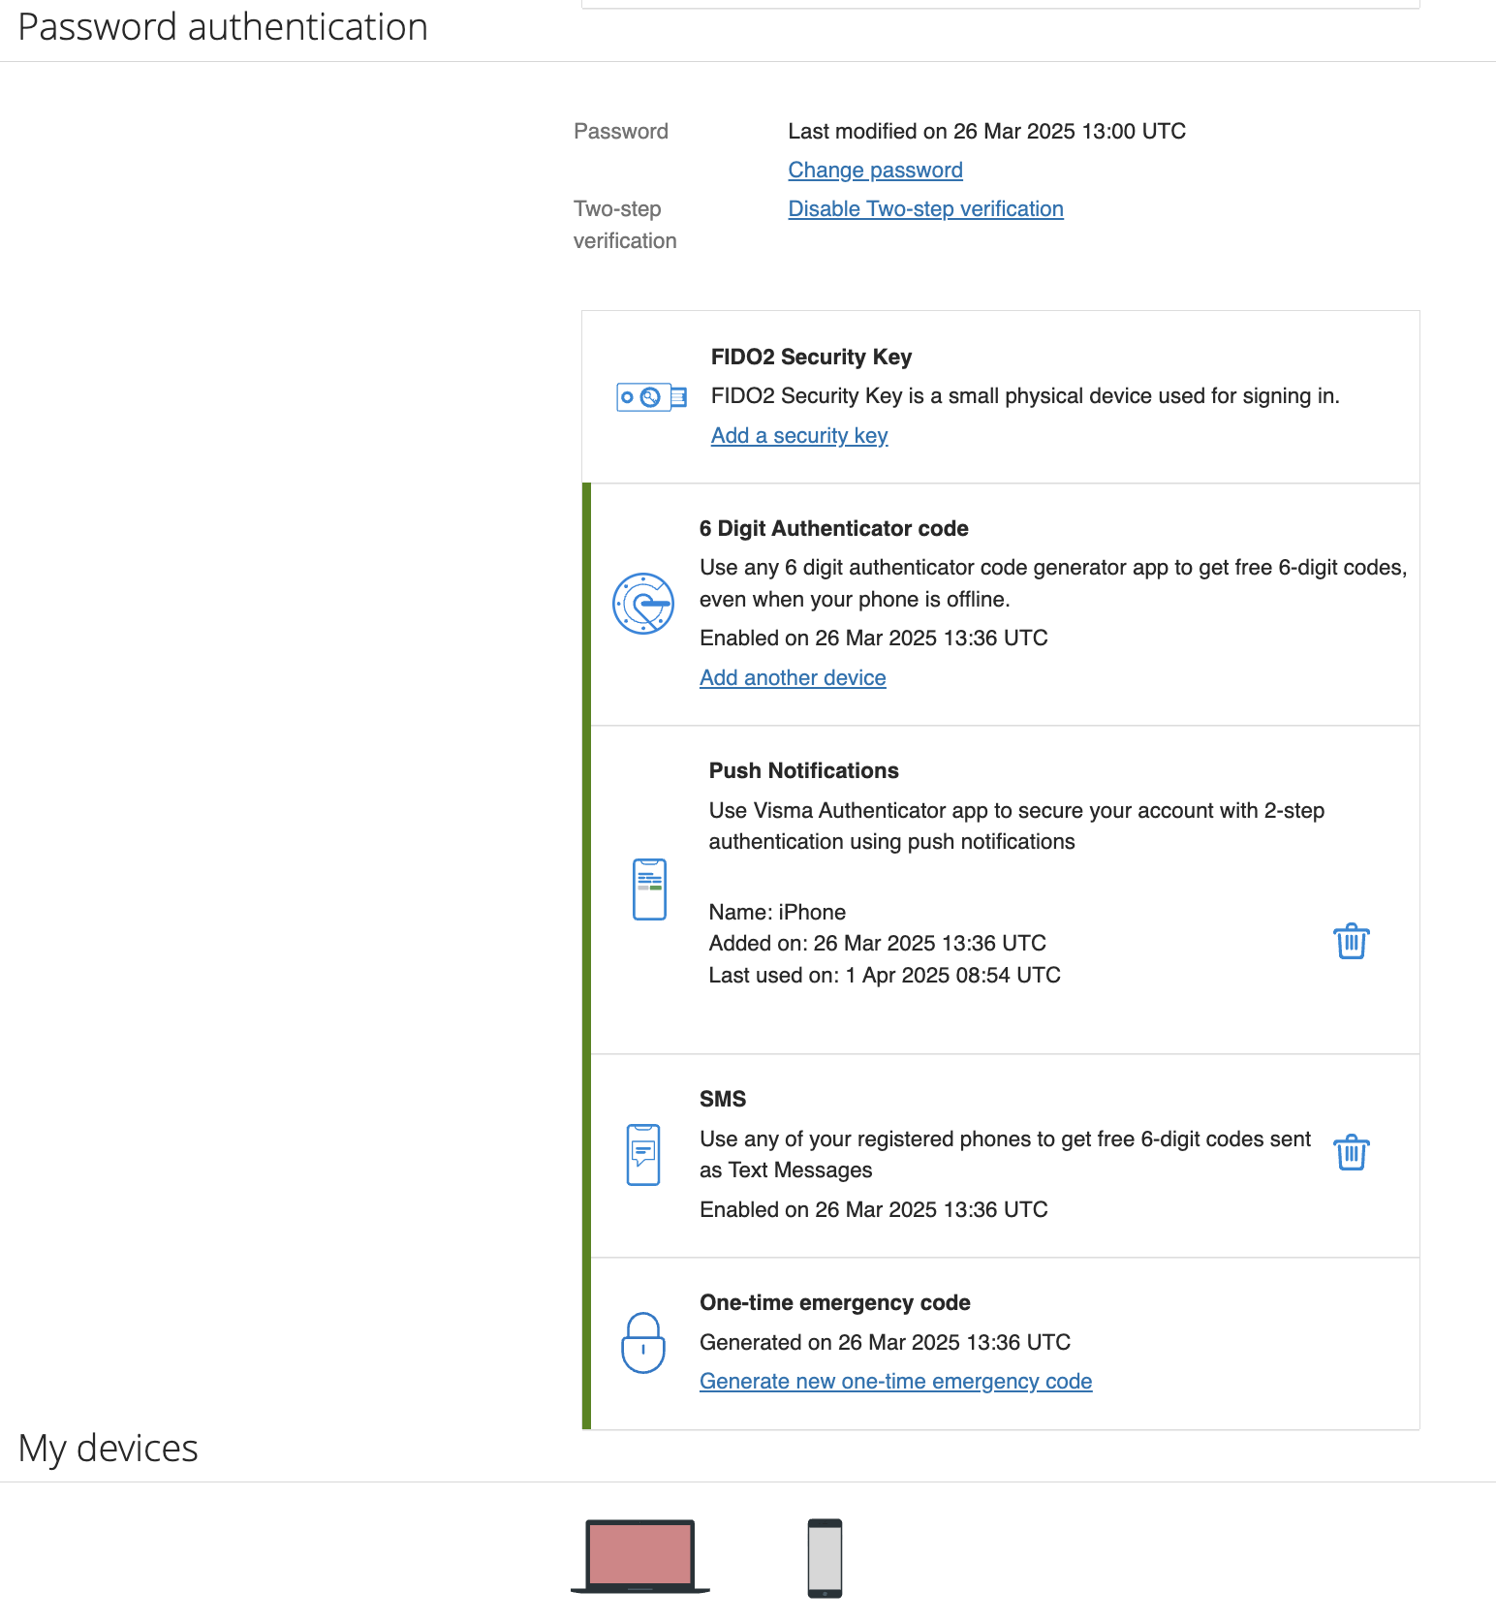

If you no longer have access to your backup code, please contact your YouServe administrator.

Use the backup code
If you do not have access to your device for two-factor authentication when logging in, you can click on the link 'Try another way'. Then choose Use backup code.

